**UNIT 3 & 4 CHEM Name: _______________**

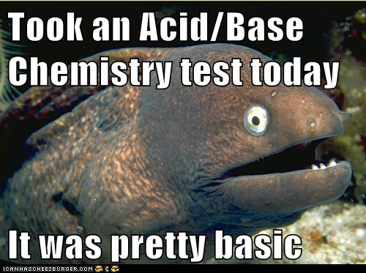

**MODULE 2:**   
ACIDS & BASES

Syllabus dot-points

**Science as a Human Endeavour:**

**Ocean acidification:**Levels of carbon dioxide in the atmosphere are rising and have a significant impact on global systems, including surface temperatures. The increasing level of carbon dioxide in the atmosphere causes more carbon dioxide to dissolve in the ocean producing carbonic acid and leading to increased ocean acidity. This is predicted to have a range of negative consequences for marine ecosystems such as coral reefs. Calcification is the process which results in the formation of calcium carbonate structures in marine organisms. Acidification shifts the equilibrium of carbonate chemistry in seawater, decreasing the rate and amount of calcification among a wide range of marine organisms. The United Nations Kyoto Protocol and the Intergovernmental Panel on Climate Change aim to secure a global commitment to reducing greenhouse gas emissions over the next few decades.

**Models of acids and bases:**Models and theories are contested and refined or replaced when new evidence challenges them, or when a new model or theory has greater explanatory scope. Davy initially proposed that acids were substances that contained replaceable hydrogen (hydrogen that could be partly or totally replaced by metals) and bases were substances that reacted with acids to form salts and water. The Arrhenius model, which includes only soluble acids and bases, identified acids as substances which produce hydrogen ions in solution and bases as substances which produce hydroxide ions in solution. Subsequently, the Brønsted-Lowry model describes acid-base behaviour in terms of proton donors and proton acceptors. This approach includes a wider range of substances and can be more broadly applied.

**Science Understanding:**

* acids are substances that can act as proton (hydrogen ion) donors and can be classified as monoprotic or polyprotic, depending on the number of protons available for donation
* the relationship between acids and bases in equilibrium systems can be explained using the Brønsted-Lowry model and represented using chemical equations that illustrate the transfer of protons between conjugate acid-base pairs
* the strength of acids is explained by the degree of ionisation at equilibrium in aqueous solution which can be represented by chemical equations and acidity constants (Ka)
* acid-base indicators are weak acids, or weak bases, in which the acidic form is a different colour from the basic form
* the hydrolysis of salts of weak acids and weak bases can be represented using equations; the Brønsted-Lowry model can be applied to explain the acidic, basic and neutral nature of salts derived from bases and monoprotic and polyprotic acids
* water is a weak electrolyte; the self-ionisation of water is represented by Kw = [H+][OH-] where Kw = 1.0 x 10-14 at 25 °C
* Kw can be used to calculate the concentration of hydrogen ions or hydroxide ions in solutions of strong acids or bases
* the pH scale is a logarithmic scale and the pH of a solution can be calculated from the concentration of hydrogen ions using the relationship pH = - log10 [H+]
* buffer solutions are conjugate in nature and resist changes in pH when small amounts of strong acid or base are added to the solution; buffering capacity can be explained qualitatively; Le Châtelier’s Principle can be applied to predict how buffers respond to the addition of hydrogen ions and hydroxide ions

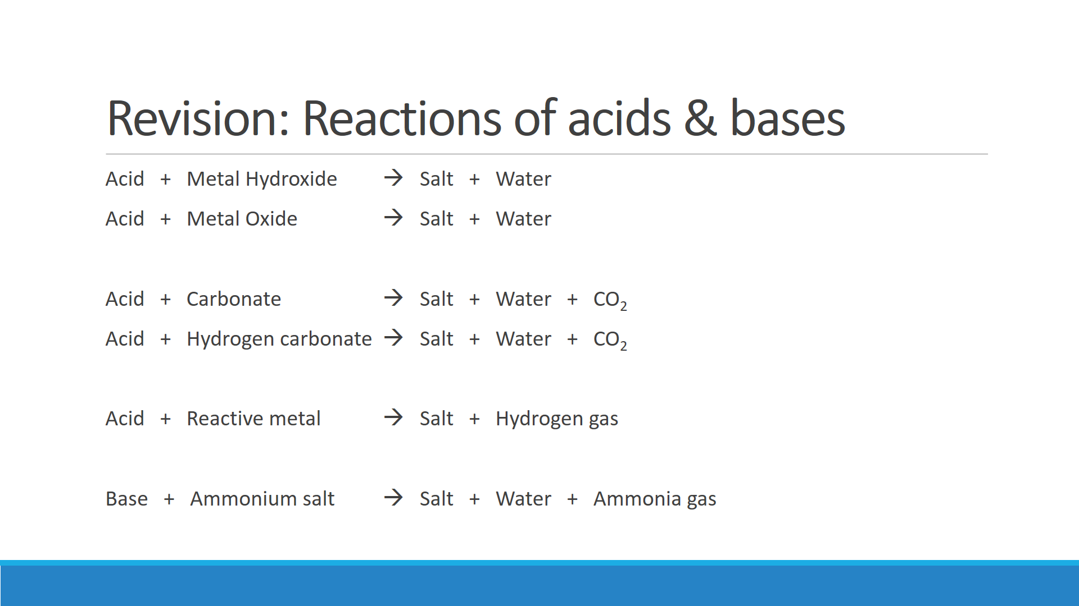

**Write molecular equations for the following reactions:**

1. Sulfuric acid is added to sodium hydroxide solution

1. Nitric acid is added to solid magnesium oxide and is heated

1. Zinc metal is reacted with concentrated hydrochloric acid

1. A model volcano is made using a reaction between acetic acid and sodium hydrogencarbonate

1. Crystals of ammonium chloride are dissolved in potassium hydroxide solution

1. Calcium carbonate in marble chips reacts with dilute nitric acid

**Write molecular equations, ionic equations and observations for the following reactions**

1. Pellets of sodium hydroxide are added to hydrochloric acid solution.

**Molecular Equation:**

**Ionic Equation:**

**Observation:**

1. Acetic acid is used to dissolve solid copper carbonate.

**Molecular Equation:**

**Ionic Equation:**

**Observation:**

1. A piece of magnesium is placed in a solution of sulfuric acid.

**Molecular Equation:**

**Ionic Equation:**

**Observation:**

1. Zinc oxide is dissolved in concentrated ethanoic acid

**Ionic Equation:**

**Observation:**

1. Barium hydroxide solution is used to neutralise phosphoric acid solution

**Ionic Equation:**

**Observation:**

1. Barium hydroxide solution reacts with solid ammonium nitrate

**Ionic Equation:**

**Observation:**

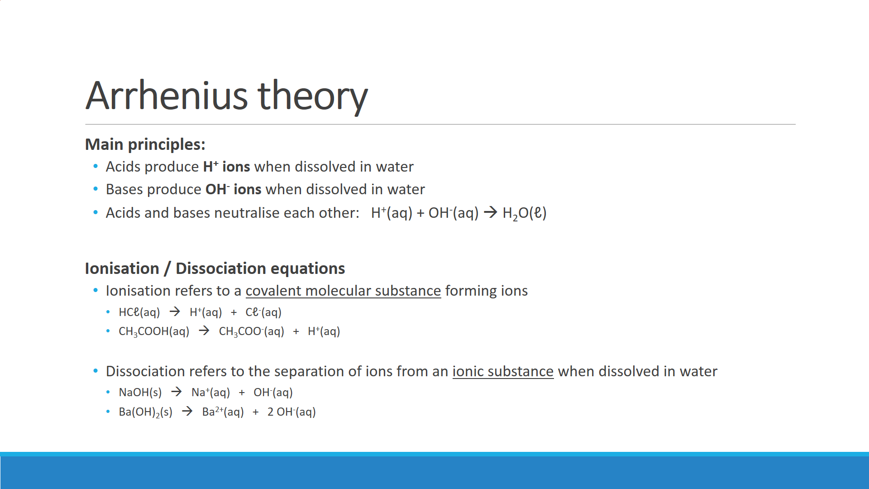

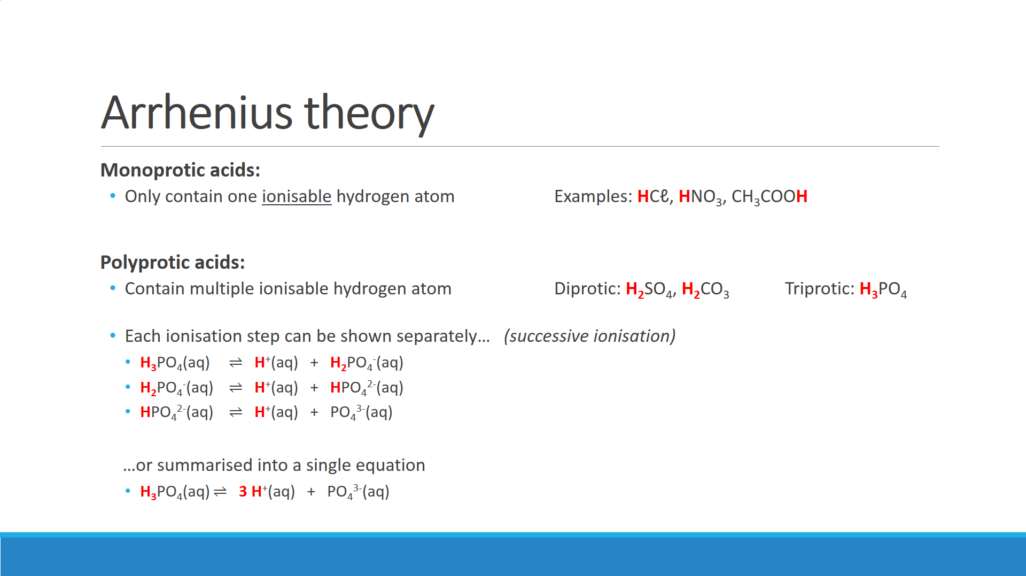

Citric acid (C6H8O7) is a weak, triprotic acid. Write successive ionisation equations for citric acid.

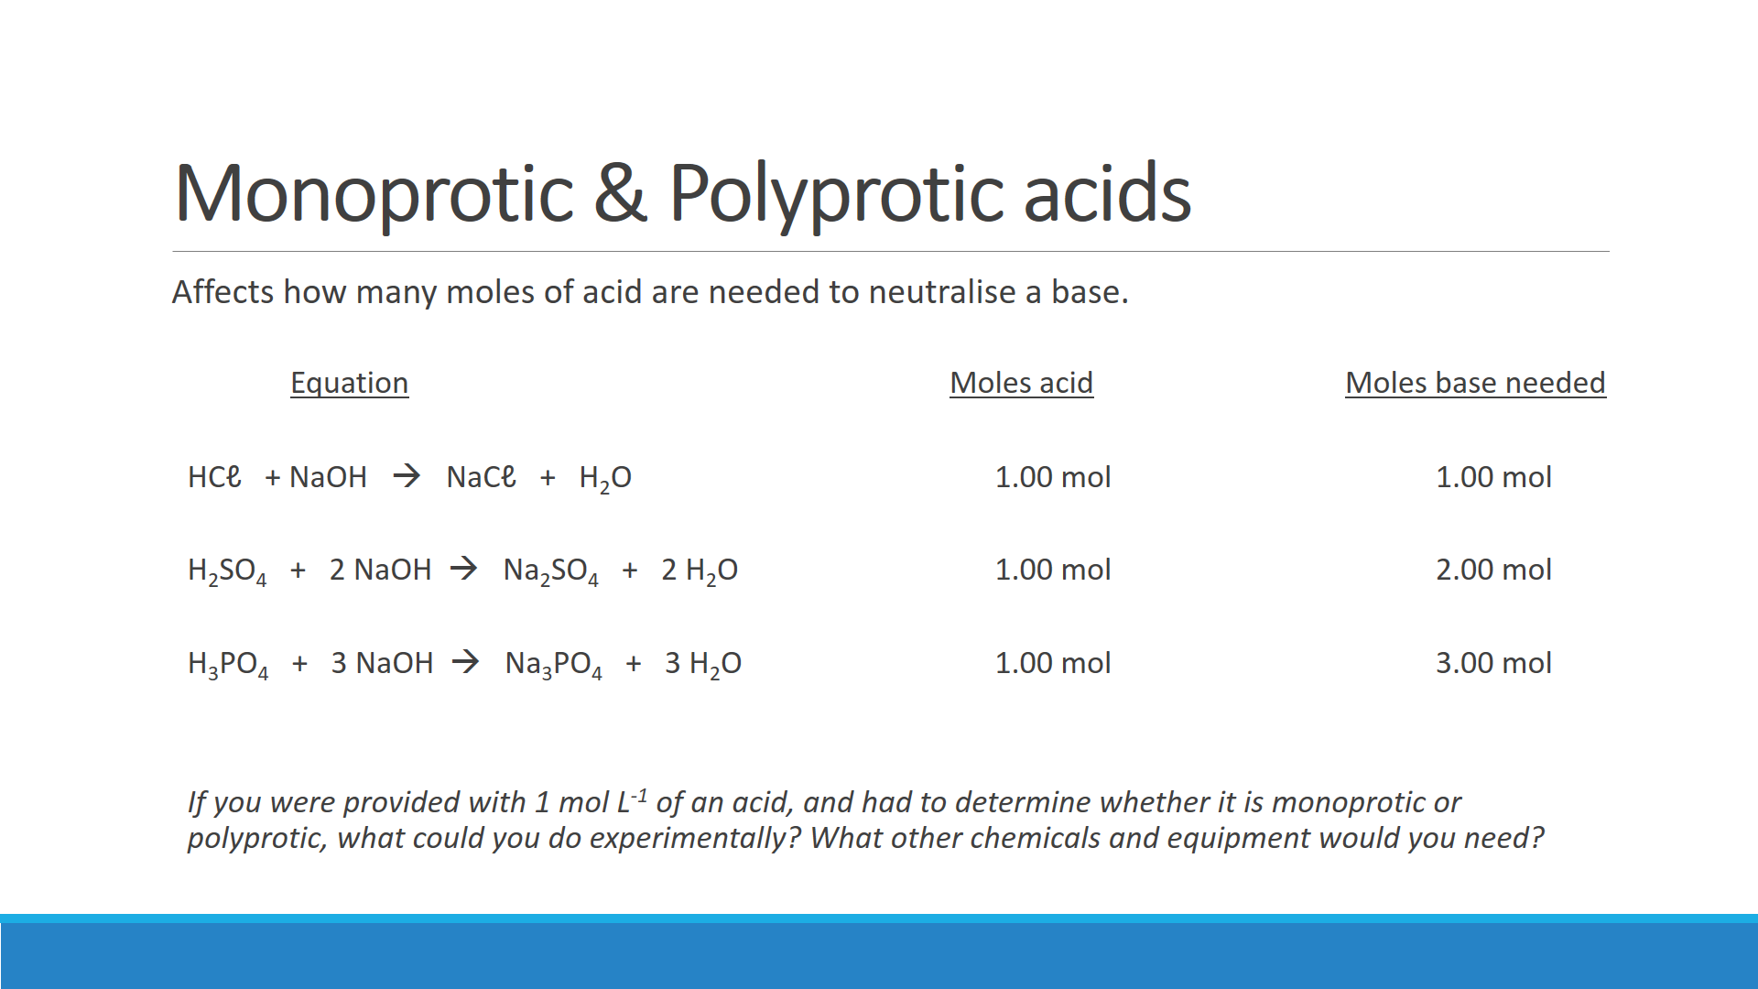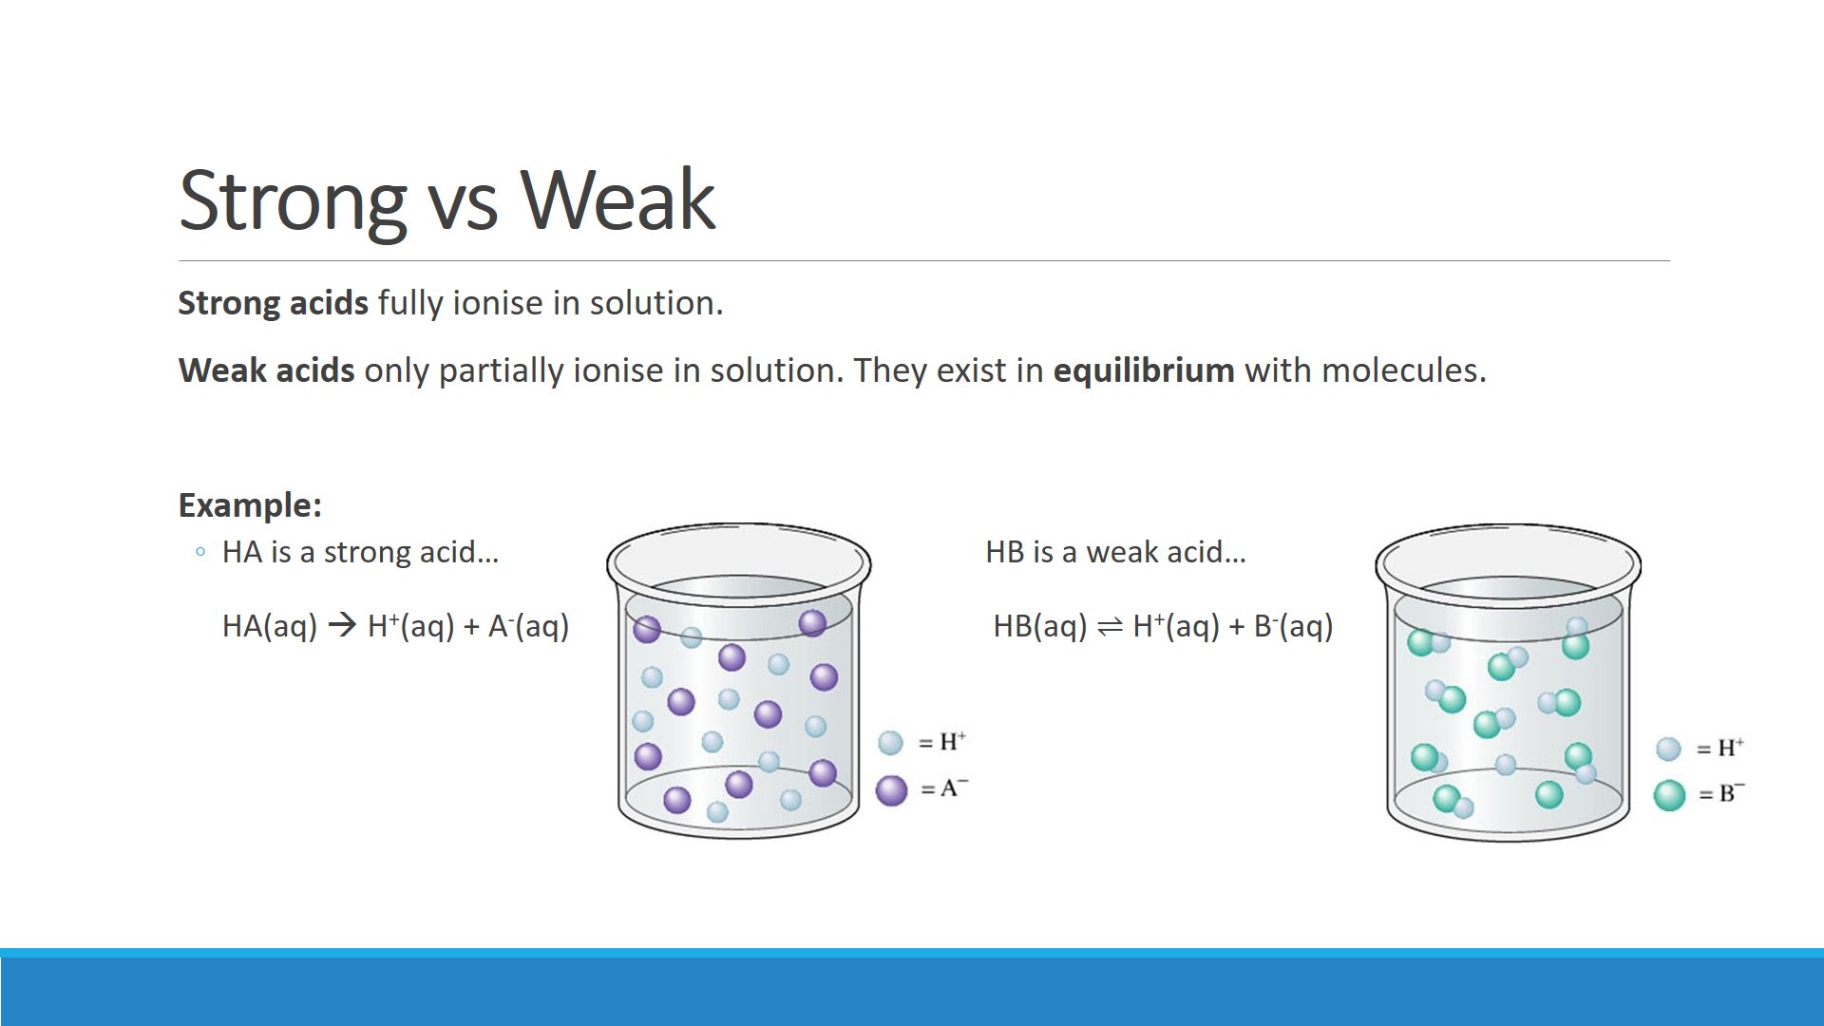

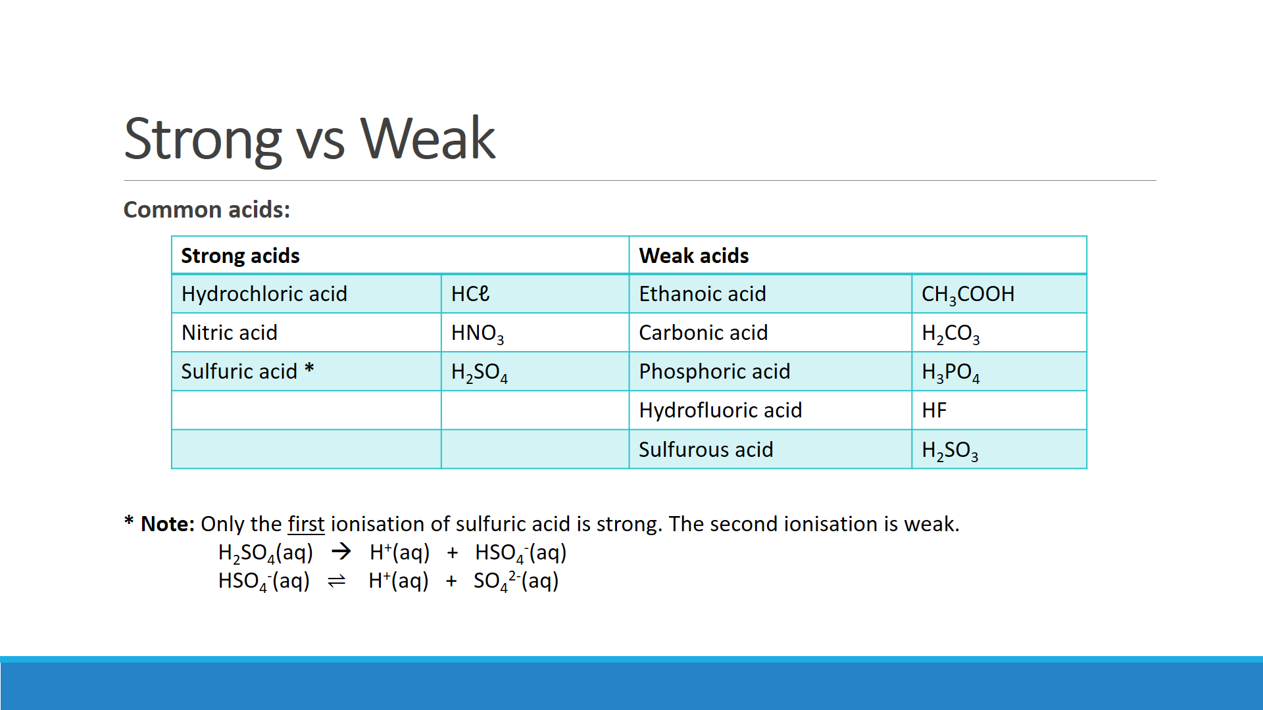

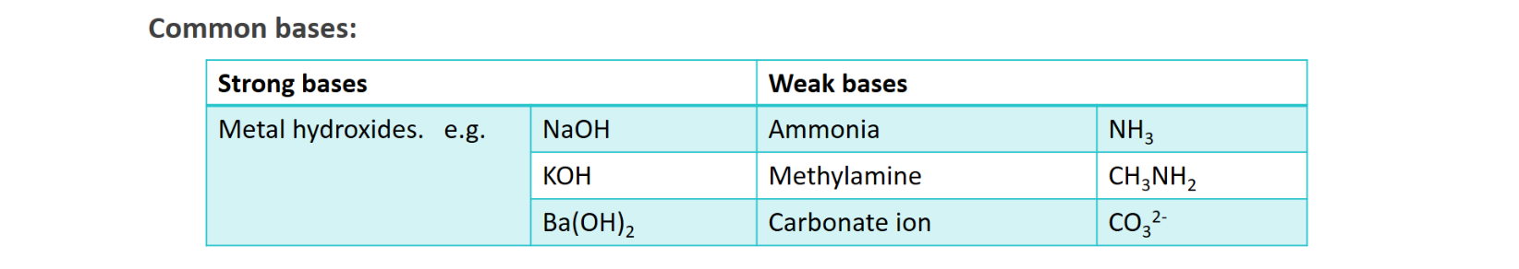

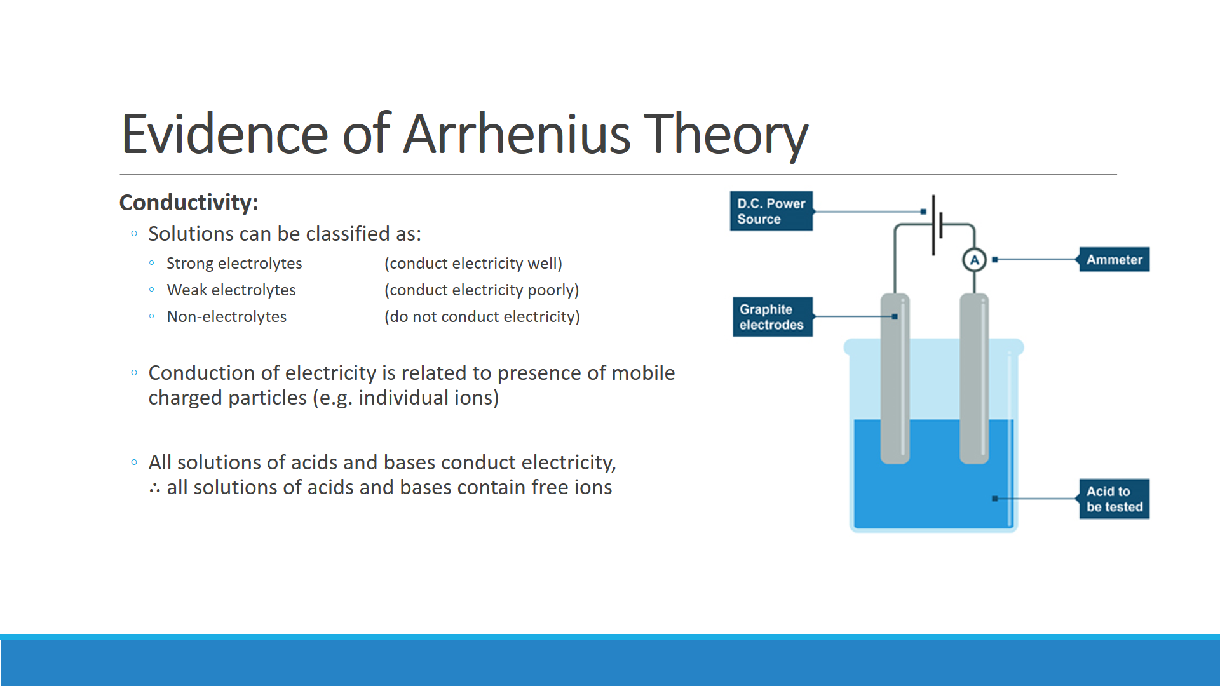

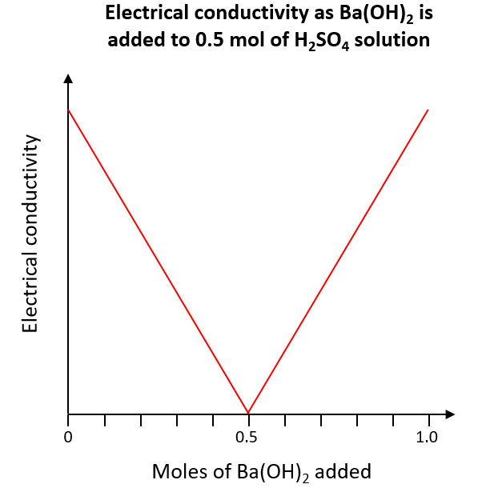

Explain why the solution of H2SO4 initially conducts electricity**:**

With the aid of an equation, explain why the conductivity of the solution decreases as Ba(OH)2(aq) is added**:**

Explain why the electrical conductivity rises after 0.5 mol of Ba(OH)2 is added**:**

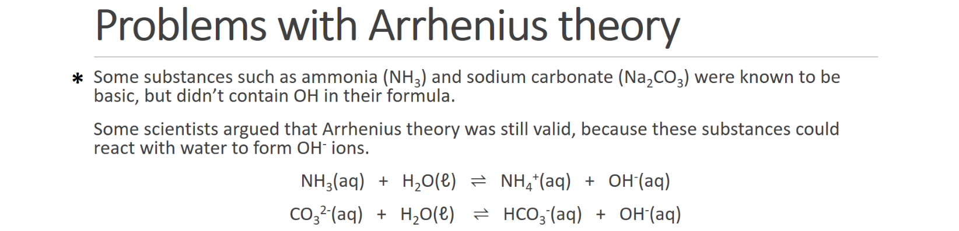

**.**



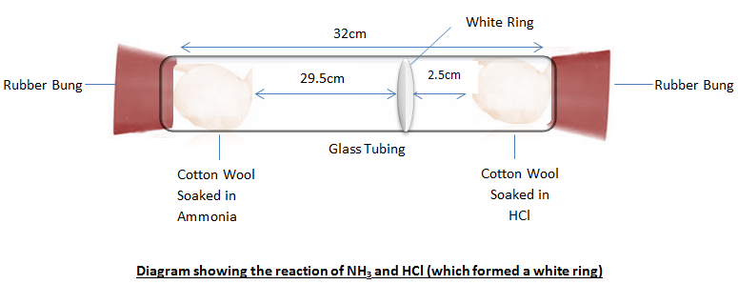

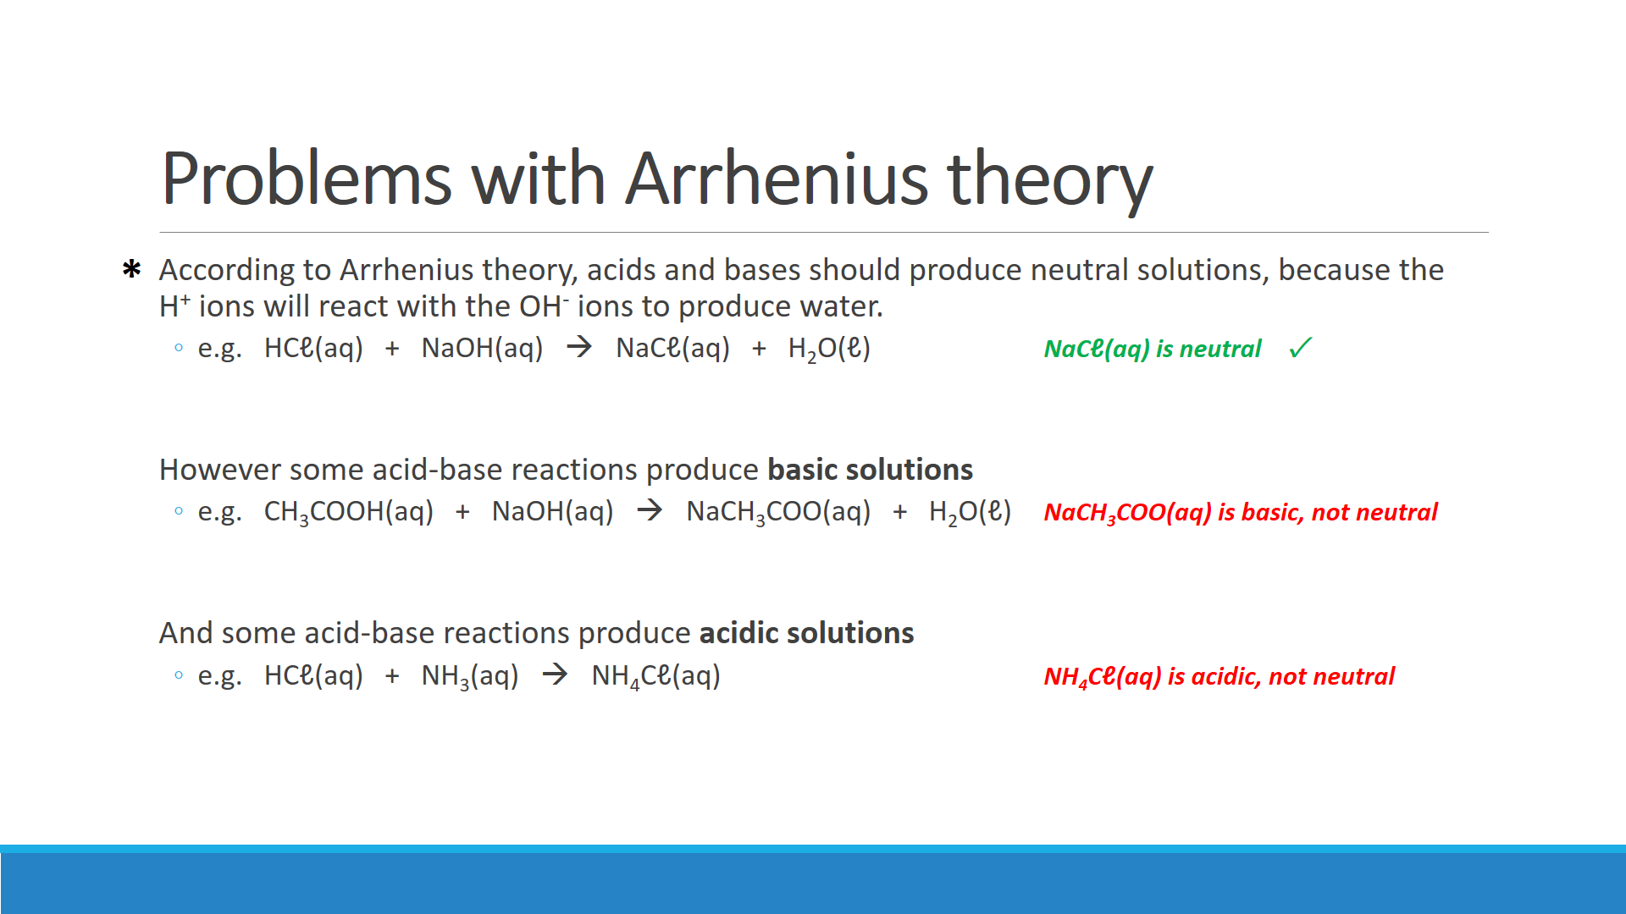

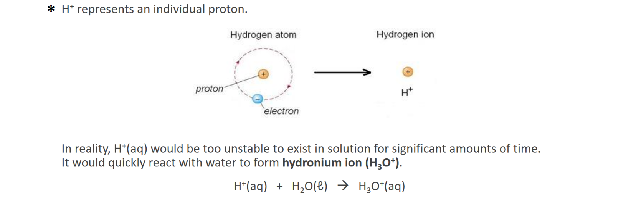

**EXPERIMENT: CONDUCTIVITY OF ACIDS AND BASES**

**Background:** Acids and bases are electrolytes, that is they conduct an electric current when in aqueous solution. For acids and bases electrolyte strength is also referred to as acid or base strength. Strong acids and bases exist essentially as ions in aqueous solution. Weak acids and bases are those in which only a small proportion of the molecules or ions react with water to form hydronium ions, H3O+ (hydrogen ion attached to a water molecule) or hydroxide ions, OH- in aqueous solution.

**Aim:** To investigate the electrical conductivity of acid and base solutions of different strengths and concentrations.

**Equipment:**

* Power supply
* Plate electrode system
* Ammeter
* Electrical leads (three)
* Two beakers
* 50 mL samples of the following solutions:
  + Hydrochloric acid 1 mol L-1
  + Hydrochloric acid 0.1 mol L-1
  + Hydrochloric acid 0.01 mol L-1
  + Hydrochloric acid 0.001 mol L-1
  + Nitric acid 1 mol L-1
  + Acetic acid 1 mol L-1
  + Sodium hydroxide 1 mol L-1
  + Ammonia 1 mol L-1

**Method:**

1. Set up the circuit and the electrodes as shown to the right.   
   Set the power supply to **6 V DC**.  
     
   **CAUTION:** Connect the red terminal of the power supply to the red terminal of the ammeter that uses the least sensitive scale. If the reading is less than the full scale reading of the next more sensitive scale switch the red terminal to use that more sensitive scale.
2. Place 50 mL of 1 mol L-1 HCℓ in a beaker, put the electrodes in the solution and briefly turn on the power pack.
3. Record the reading on the ammeter.
4. Wash out the beaker and electrodes with distilled water and then in turn test the conductivity of the other solutions.

**Results:**

|  |  |  |  |
| --- | --- | --- | --- |
| **Acid** | **Concentration  (mol L-1)** | **Acid/base strength  (strong or weak?)** | **Ammeter reading** |
| Hydrochloric acid (HCℓ) | 1 |  |  |
| 0.1 |  |  |
| 0.01 |  |  |
| 0.001 |  |  |
| Nitric acid (HNO3) | 1 |  |  |
| Acetic acid (CH3COOH) | 1 |  |  |
| Sodium hydroxide (NaOH) | 1 |  |  |
| Ammonia (NH3) | 1 |  |  |

**Questions:**

1. Explain why these solutions conduct an electric current

1. Look at your results for the HCℓ solutions. What conclusion can you draw regarding the conductivity of a solution and the concentration of ions in it?

1. Were the conductivities of 1.0 mol L-1 HCℓ and 1.0 mol L-1 CH3COOH different? If so, explain why they were different.

1. Were the conductivities of 1.0 mol L­-1 NaOH and 1.0 mol L-1 NH3 different? If so, explain why they were different.

1. Acids and bases are referred to as being ‘strong’ or ‘weak’ as distinct from being ‘concentrated’ or ‘dilute’. Explain how these two variables (electrolyte strength and solution concentration) affect the conductivity of aqueous solutions.

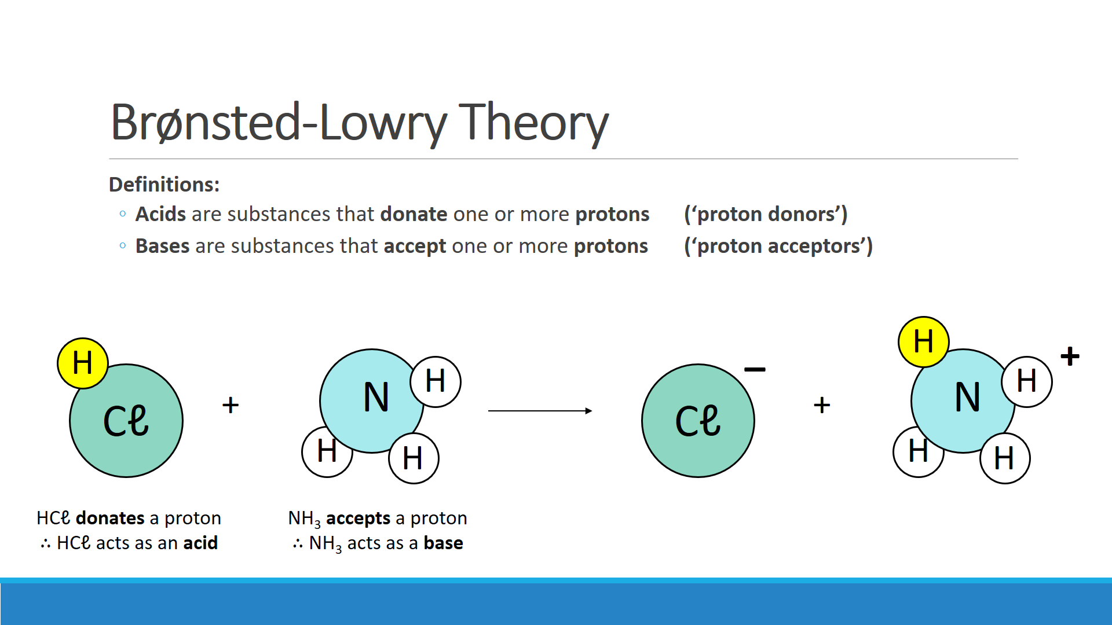

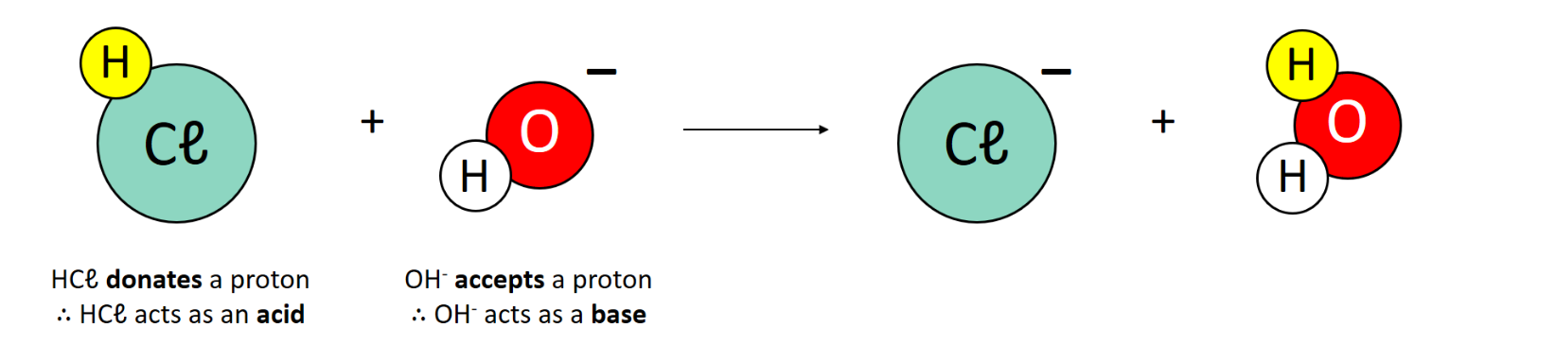

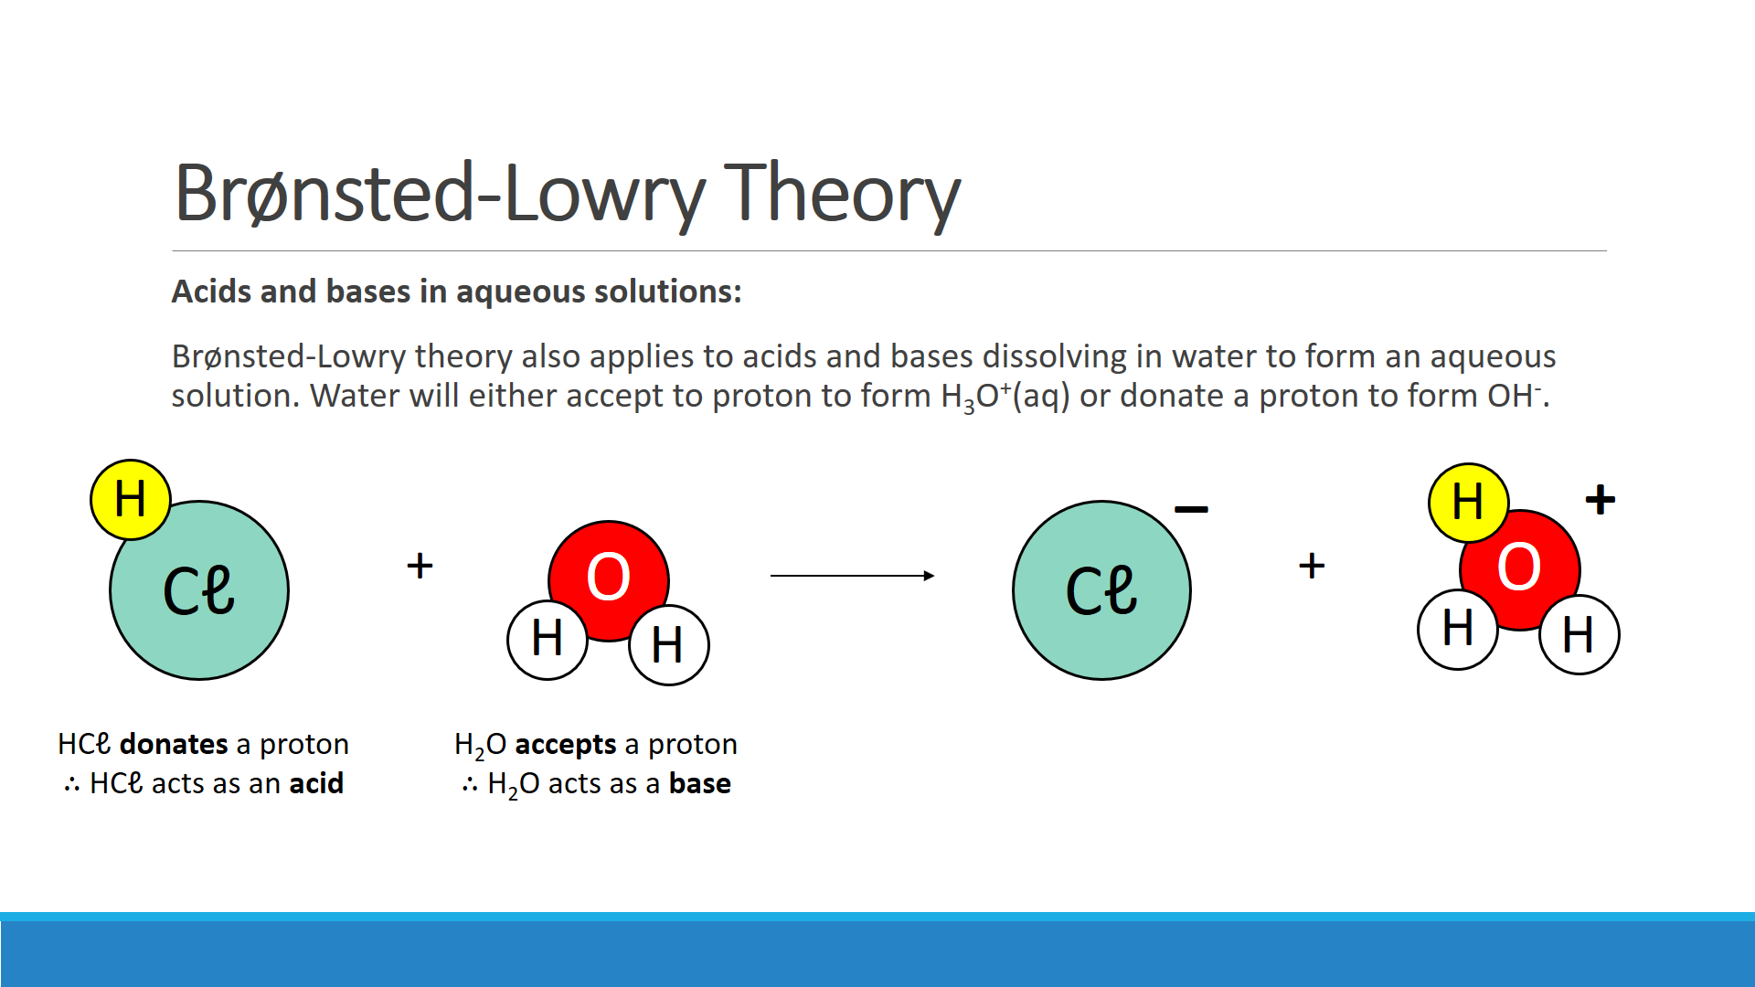

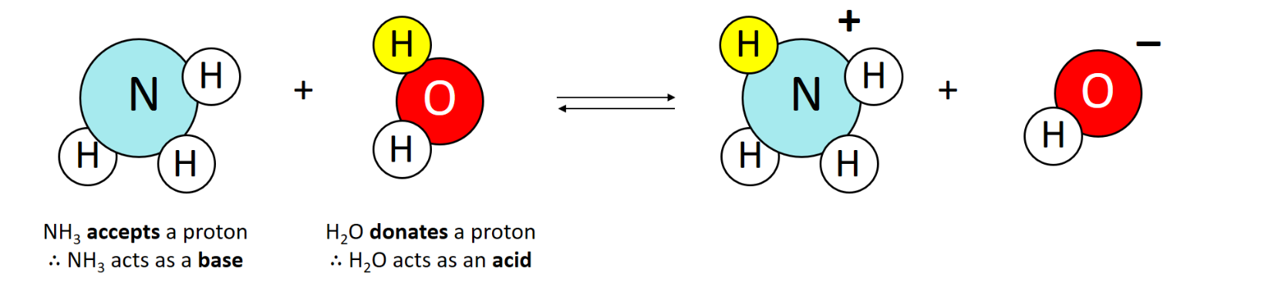



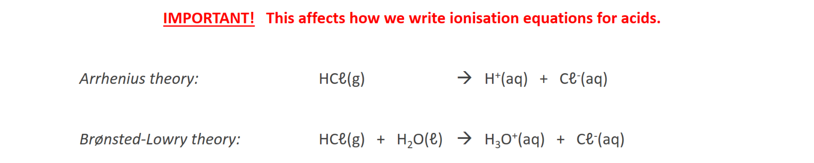

**Question:**

* Write an ionisation equation using Arrhenius theory
* Write an ionisation equation using Brønsted-Lowry theory

|  |  |
| --- | --- |
| **Nitric acid** | Arrhenius theory: |
| Brønsted-Lowry theory: |

|  |  |
| --- | --- |
| **Hydrofluoric acid** | Arrhenius theory: |
| Brønsted-Lowry theory: |

|  |  |
| --- | --- |
| **Carbonate ion**  *(weak base)* | Brønsted-Lowry theory: |

|  |  |
| --- | --- |
| **Methylamine (CH3NH2)**  *(weak base)* | Brønsted-Lowry theory: |

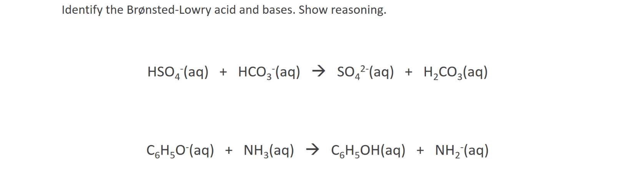

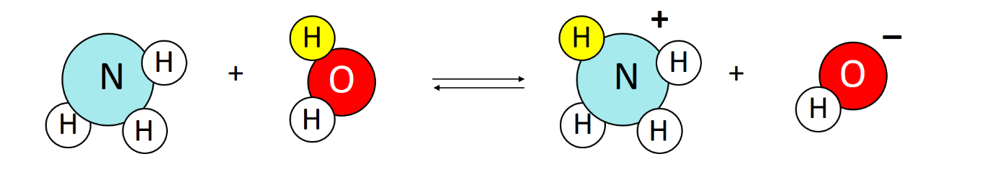

**____________ ___________ ___________ ___________**

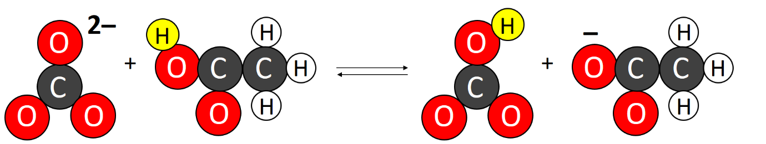

**____________ ___________ ___________ ___________**

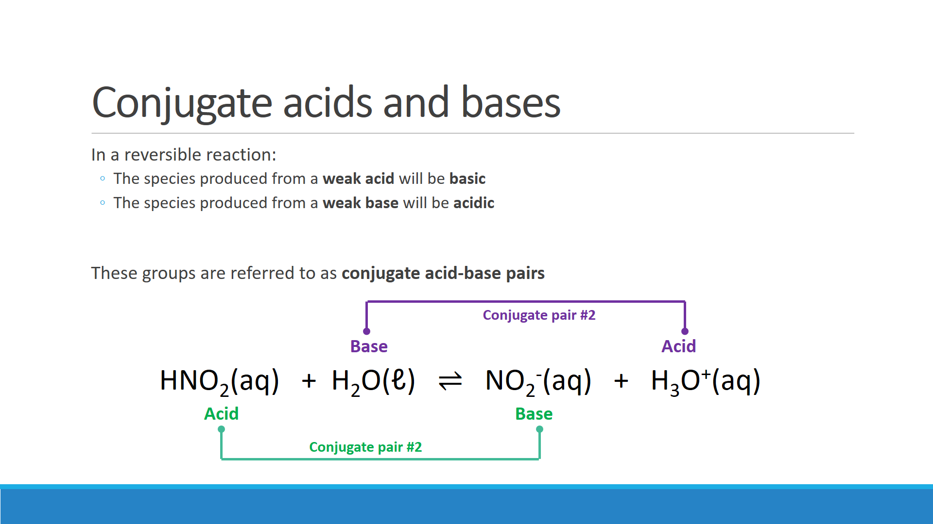

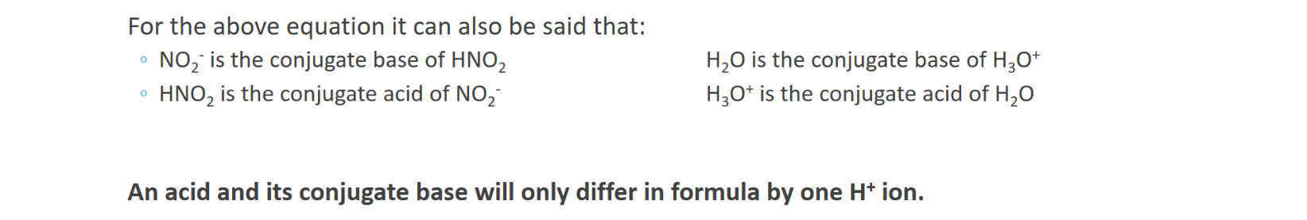

**Brønsted-Lowry review questions:**

1. Which of the following reactions are regarded as Brønsted-Lowry acid-base reactions?   
   For these reactions identify which reactant is acting as the Brønsted-Lowry acid and which is acting as the Brønsted-Lowry base.  
   1. SO32-(aq) + H2O(ℓ) ⇌ HSO3-(aq) + OH-(aq)
   2. HS-(aq) + NH3(aq) 🡪 NH4+(aq) + S2-(aq)
   3. H2O2(aq) + H2O2(aq) 🡪 2 H2O(ℓ) + O2(g)
   4. H2O(ℓ) + H2O(ℓ) ⇌ H3O+(aq) + OH-(aq)

1. Write equations for the dihydrogenphosphate ion reacting with water as a:  
   1. Brønsted-Lowry acid

* 1. Brønsted-Lowry base

1. The hydrogensulfide ion, HS-, is amphiprotic.
   1. What is meant be the word ‘amphiprotic’?

* 1. When HS- is added to hydrochloric acid, it acts as a Brønsted-Lowry base. Write the equation for the reaction between HS-(aq) and the hydronium ions in the hydrochloric acid.

* 1. HS- acts as a Brønsted-Lowry acid when it is added to a solution of sodium hydroxide. Write an equation for the reaction between HS-(aq) and the hydroxide ions in the sodium hydroxide solution

1. Complete the tables by giving the formula of the conjugate acids/bases.

|  |  |
| --- | --- |
| **Acid** | **Conjugate base** |
| HI |  |
| HNO2 |  |
| HCO3- |  |
| PH4+ |  |

|  |  |
| --- | --- |
| **Base** | **Conjugate acid** |
| SO32- |  |
| O2- |  |
| HF |  |
| NH3 |  |

1. Draw lines linking the conjugate acid-base pairs in the following reactions. Label each species as being an acid or a base.

HCN(g) + OH-(aq) ⇌ CN-(aq) + H2O(ℓ)

H2SO4(ℓ) + HNO3(ℓ) ⇌ H­3SO4+(ℓ) + NO3-(ℓ)

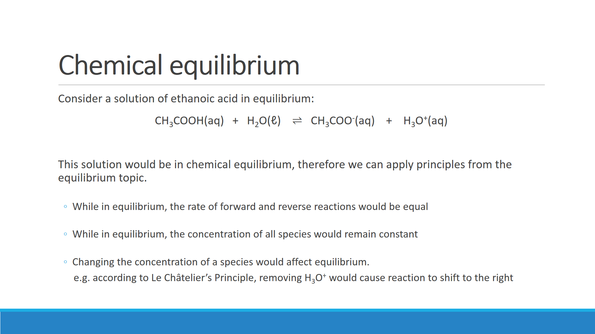

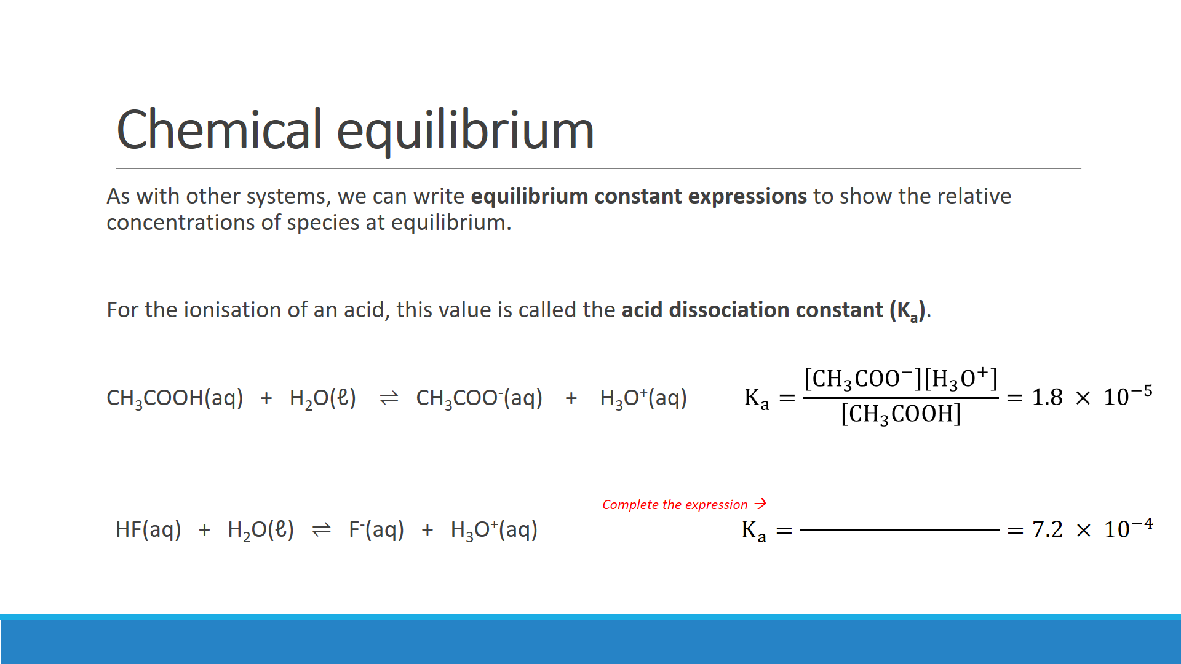

1. What does the size of the acid dissociation constant (Ka) for CH3COOH indicate?

1. What do the Ka vales of CH3COOH and HF indicate about their *relative* strengths? Justify your answer.

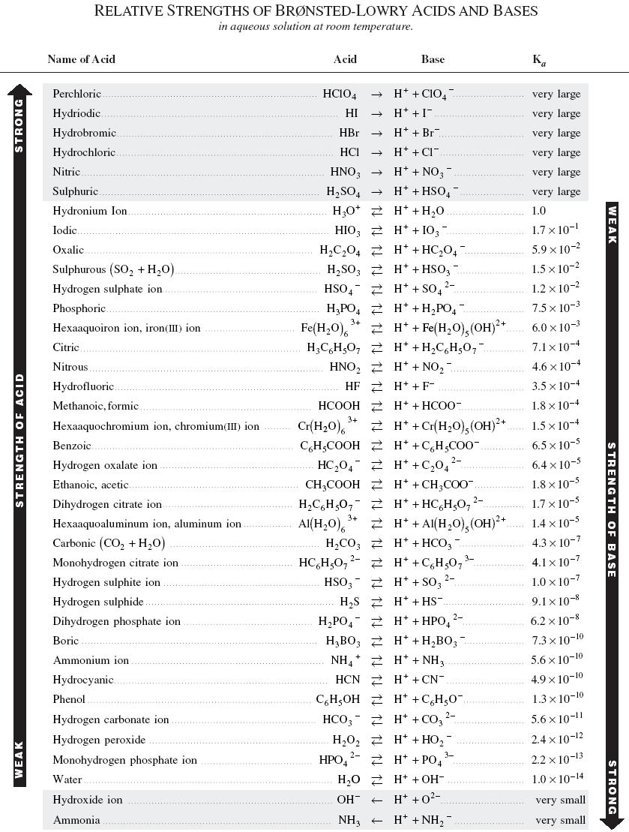

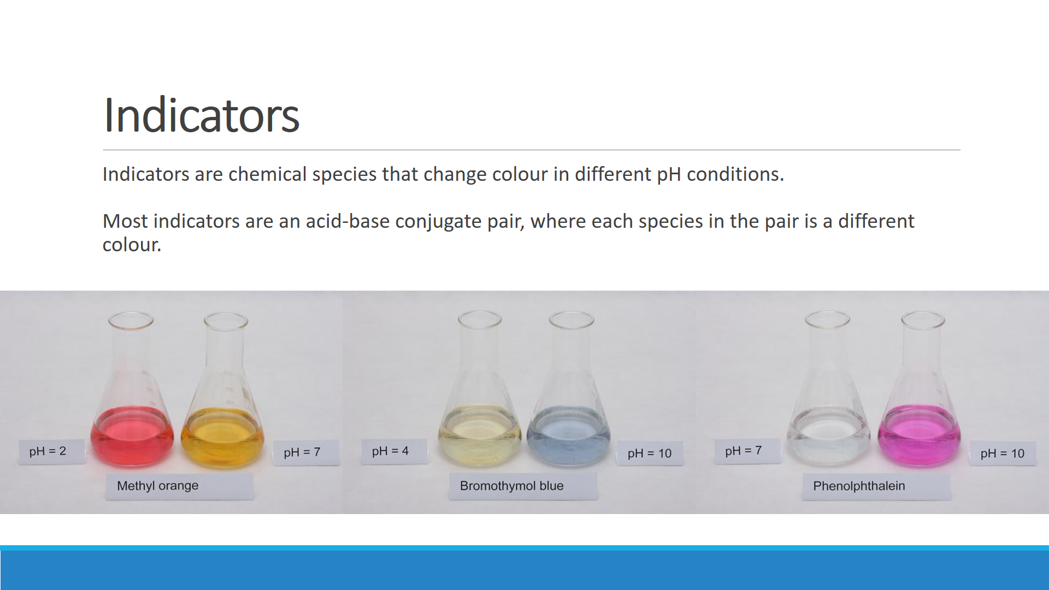

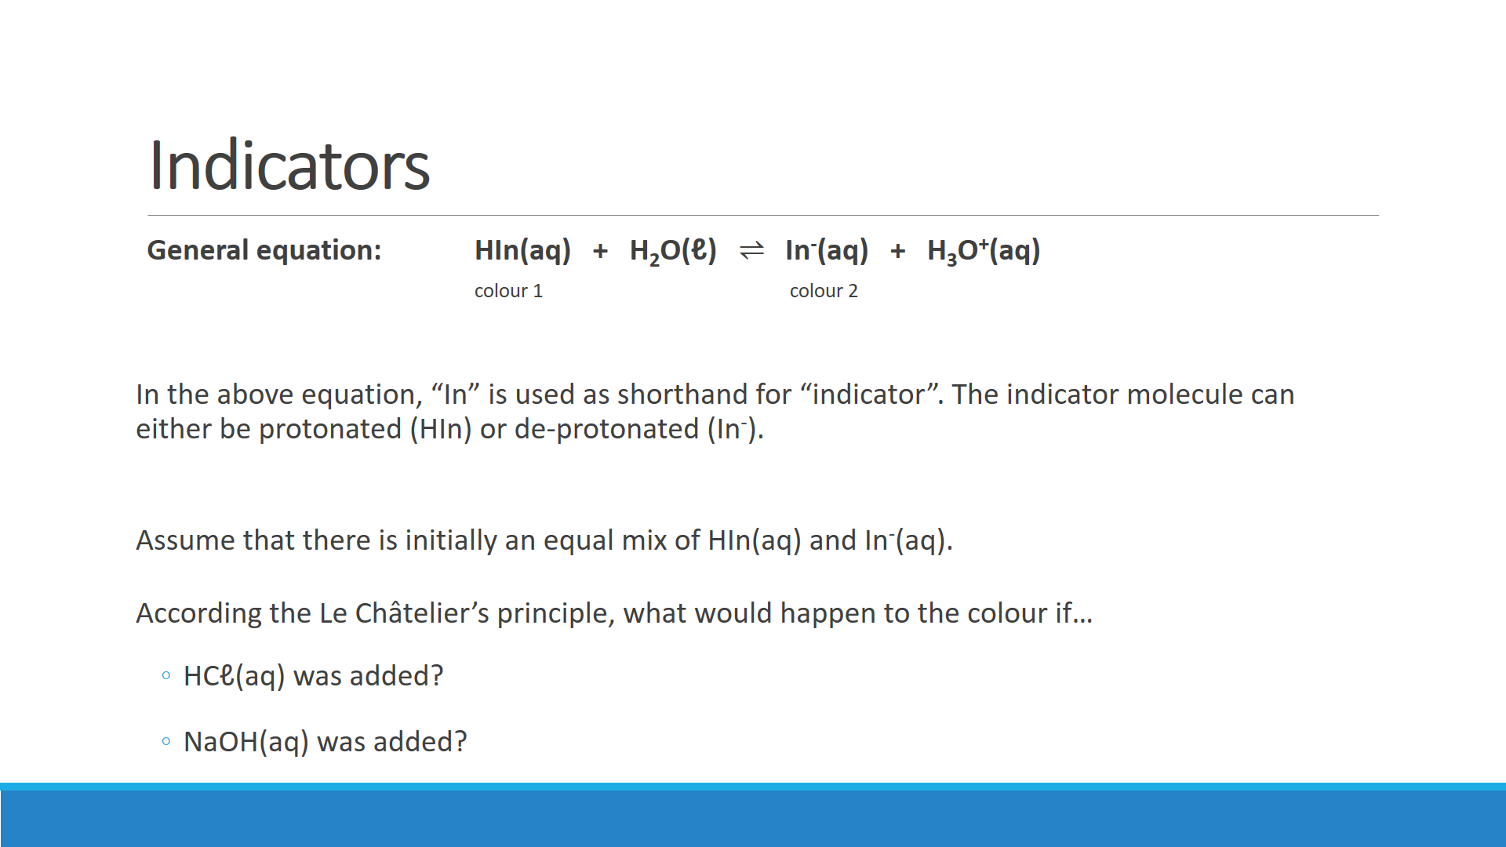

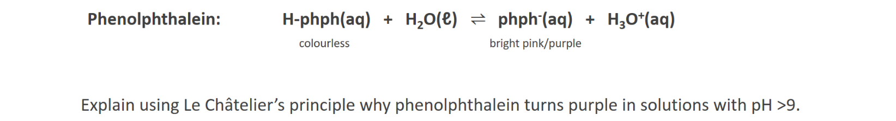

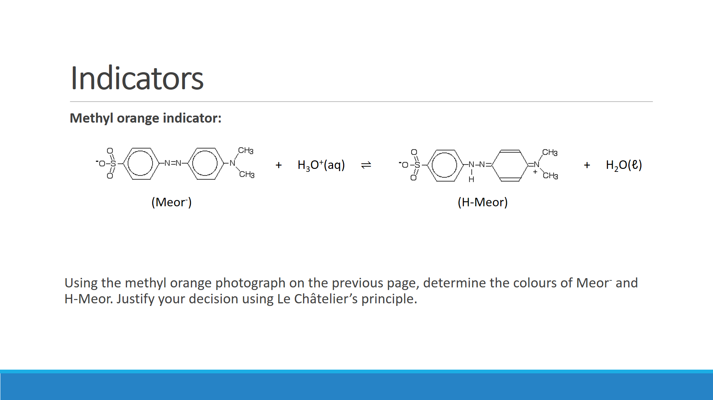

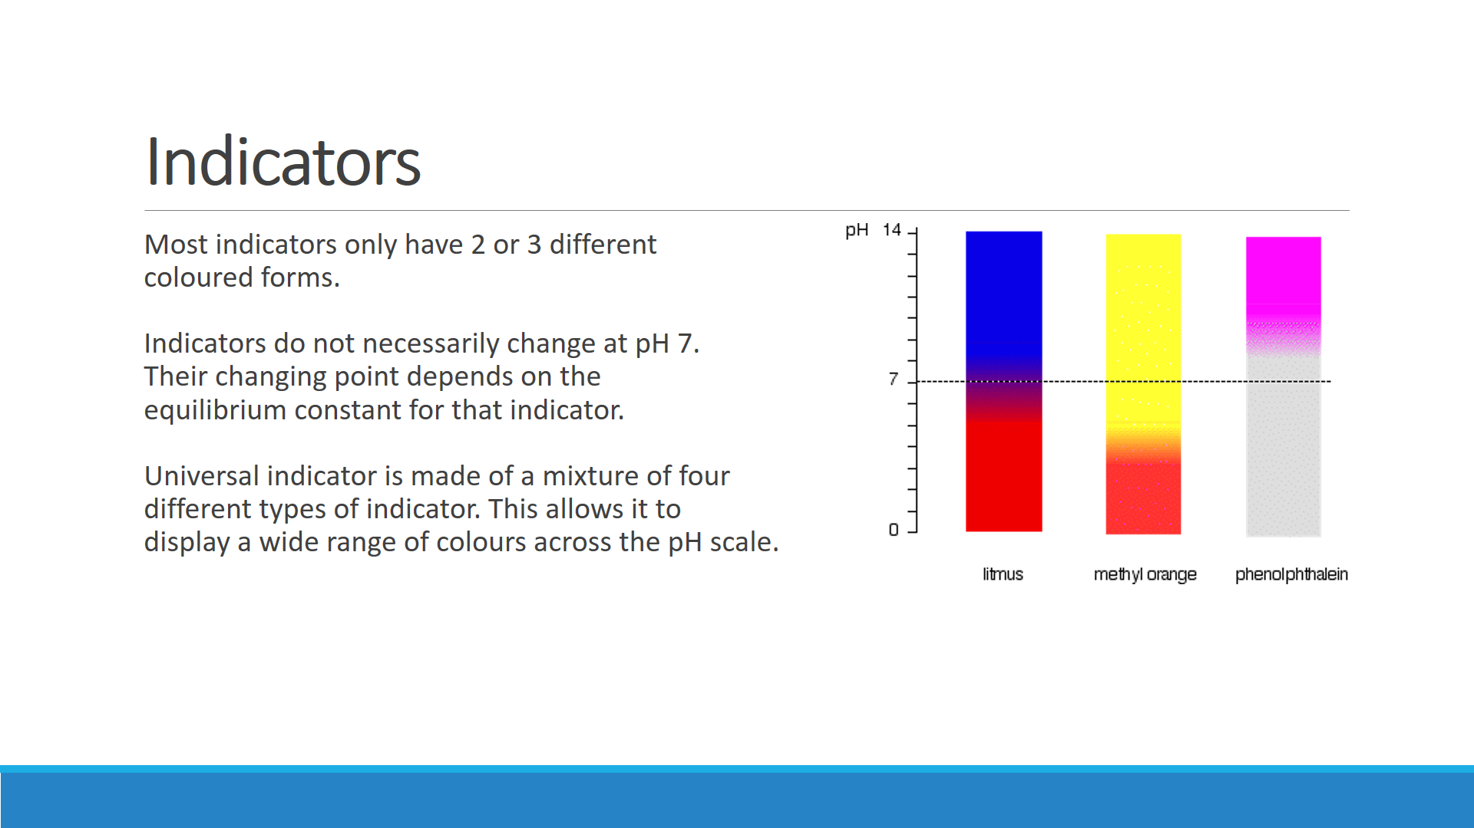

**Q:** To determine the pH of garden soil, a sample was first saturated with distilled water in a petri dish. Drops of three indicators listed below were added to separate parts of the sample. The colours observed are shown in the table.

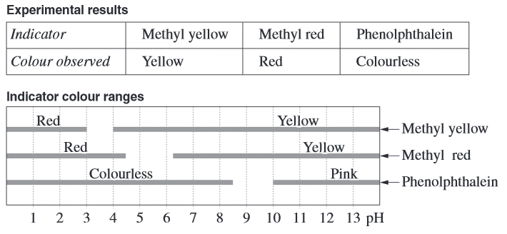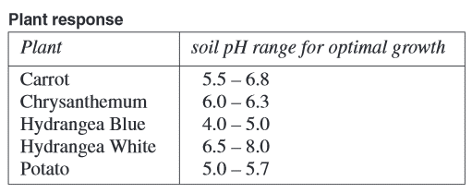

Using the information given, select the plant that will grow well at the current soil pH, and justify your selection.

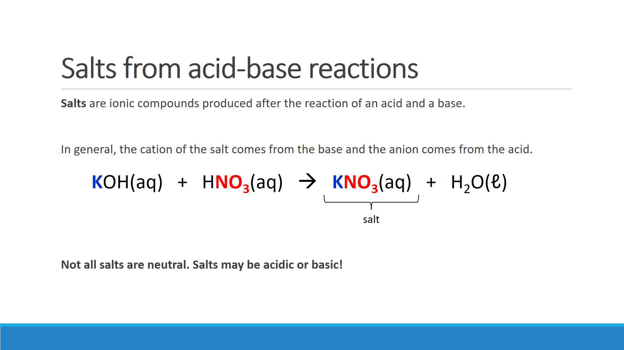

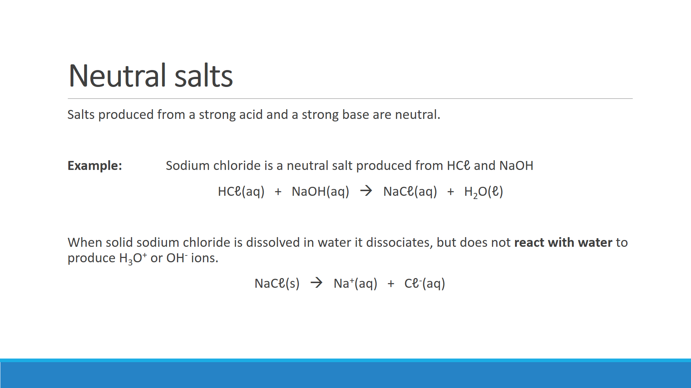

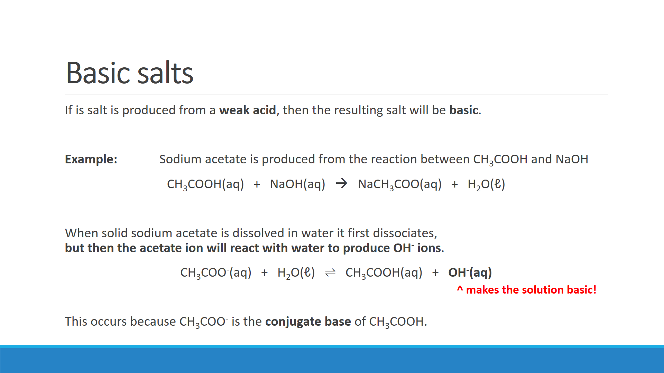

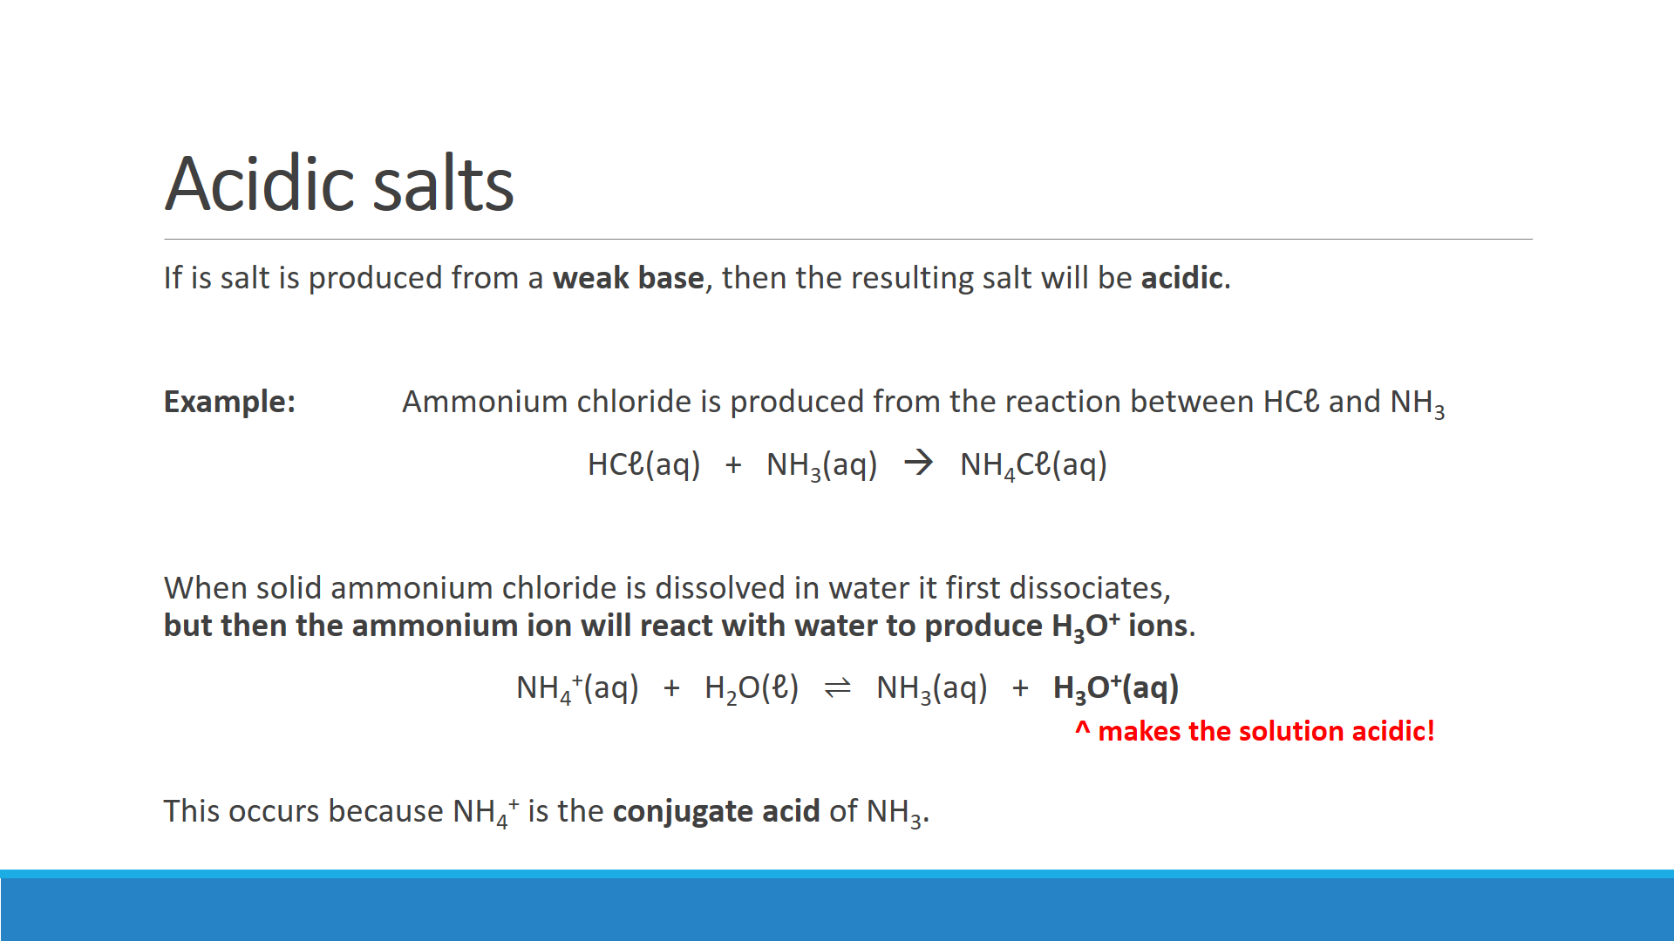

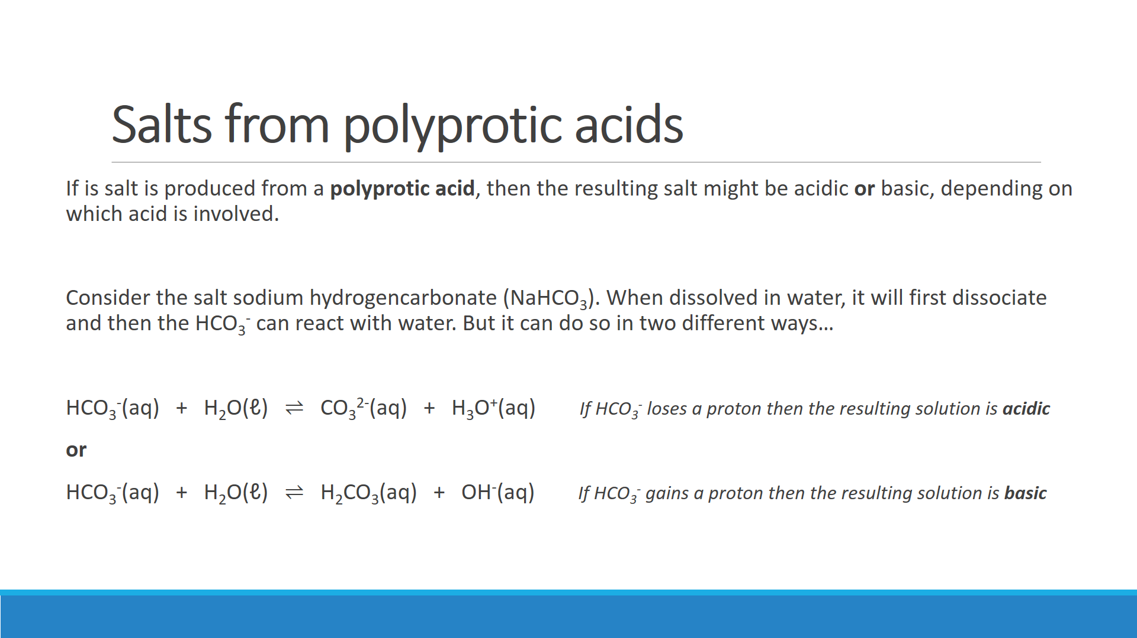

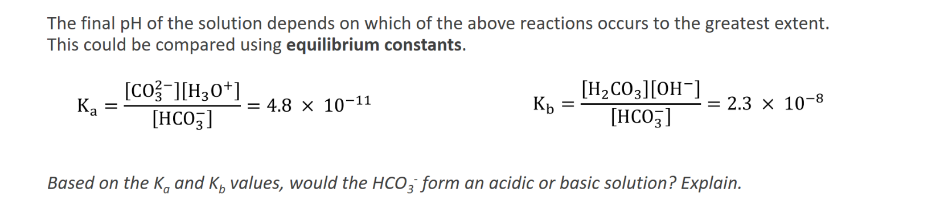

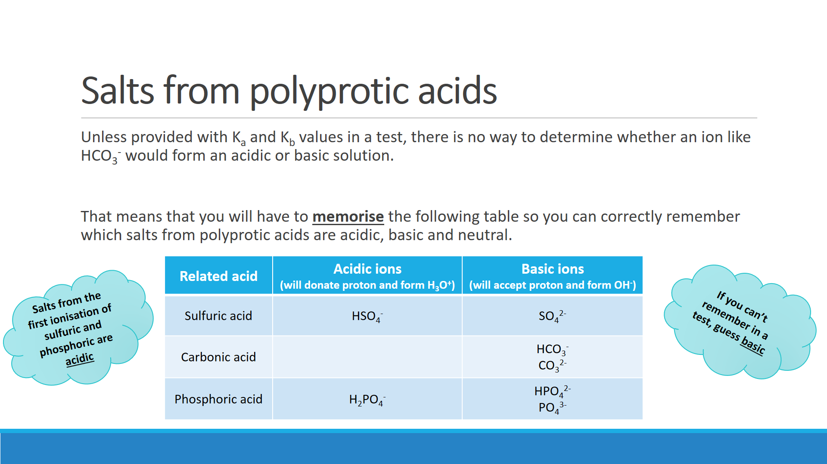

**Questions:**

1. For each of the following, state whether the solution is acidic, basic or neutral. Support your answers with hydrolysis equations where appropriate. **Hydrolysis equations are equations showing the acidic or basic species reacting with H2O.**
2. NaNO3 Acidic / Basic / Neutral

Equation:

1. NH4NO3 Acidic / Basic / Neutral

Equation:

1. KHSO4 Acidic / Basic / Neutral

Equation:

1. Ca(NO3)2 Acidic / Basic / Neutral

Equation:

1. Ca(HCO3)2 Acidic / Basic / Neutral

Equation:

1. Ammonium carbonate dissolve in water as follows:

(NH4)2CO3(s) 🡪 2 NH4+(aq) + CO32-(aq)

Following dissociation, two further reactions occur as follows:

NH4+(aq) + H2O(ℓ) ⇌ NH3(aq) + H3O+(aq)

CO32-(aq) + H2O(ℓ) ⇌ HCO3-(aq) + OH-(aq)

Indicators show that an aqueous solution of (NH4)2CO3 is basic. Explain this fact in view of the fact that there are twice as many NH4+ ions (which may produce H3O+) as there are CO32- ions (which may produce OH-) in any sample of ammonium carbonate.

The hydrolysis of carbonate must occur to a greater extent than the hydrolysis of ammonium.

i.e. If you write a Kb expression for carbonate and a Ka expression for ammonium, Kb > Ka.

It is only based on relative sizes of Kb and Ka. If the value of Ka and Kb not given still we can conclude Kb > Ka given that the final solution is basic.

**EXPERIMENT: pH OF SOME SALT SOLUTIONS**

**Background:** Salts are ionic compounds containing a cation other than H+ and an anion other than O2- or OH-. Sodium chloride (NaCℓ), potassium carbonate (K2CO3), copper(II) sulfate (CuSO4) and ammonium nitrate (NH4NO3) are all examples of salts.

When ions associated with weak acids or bases are dissolved in water they undergo hydrolysis. That is, they react with water. This can make the solution containing the salt either acidic or basic.

**Aim:** To test the pH of a number of salts dissolved in water.

**Equipment:**

* Test tubes (x8)
* Universal indicator solution and colour chart
* Approximately 2 mL of 0.1 mol L-1 solutions of various salts

**Method:**

1. Place 2 mL of each solution into separate test tubes
2. Add four drops of universal indicator and note the approximate pH of the solutions

**Results:**

|  |  |  |
| --- | --- | --- |
| **Salt solution** | **Approximate pH** | **Acidic, basic or neutral?** |
| Ammonium chloride (NH4Cℓ) |  |  |
| Sodium chloride (NaCℓ) |  |  |
| Potassium nitrate (KNO3) |  |  |
| Sodium carbonate (Na2CO3) |  |  |
| Sodium acetate (NaCH3COO) |  |  |
| Sodium hydrogencarbonate (NaHCO3) |  |  |
| Sodium sulfate (Na2SO4) |  |  |
| Sodium phosphate (Na3PO4) |  |  |

**Questions:**

1. For each of the **acidic salts**, write a hydrolysis equation to show why that solution was acidic.
2. For each of the **basic salts**, write a hydrolysis equation to show why that solution was basic.

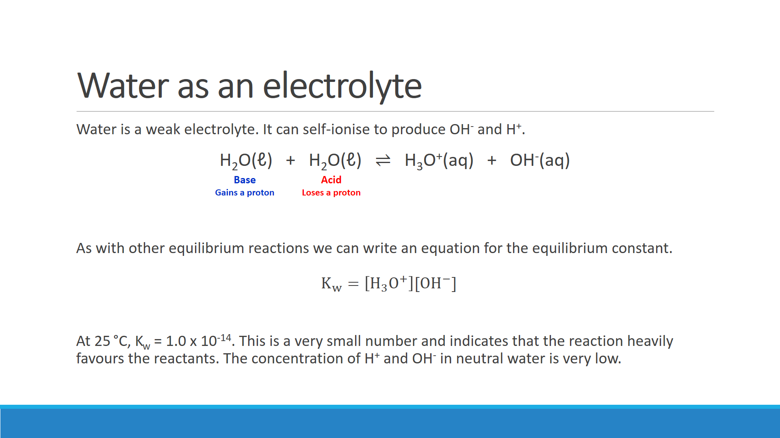

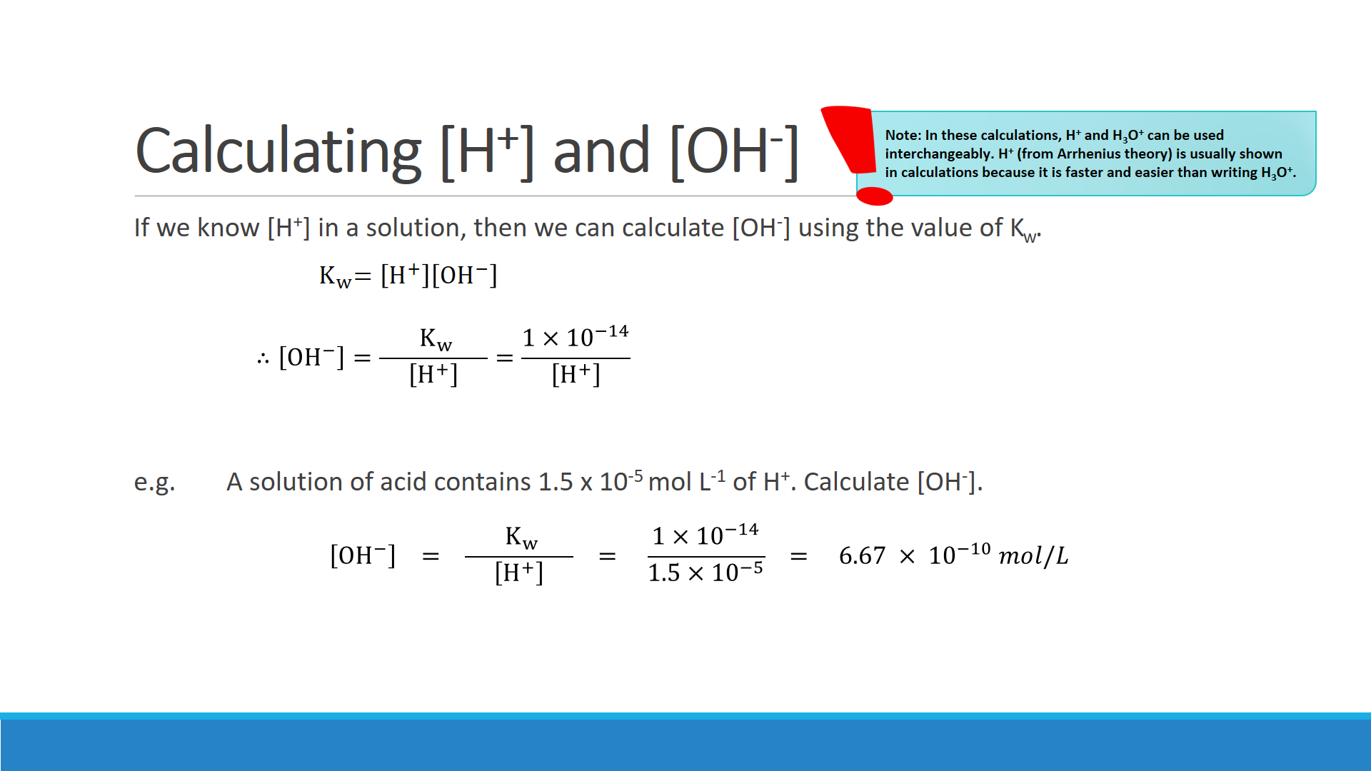

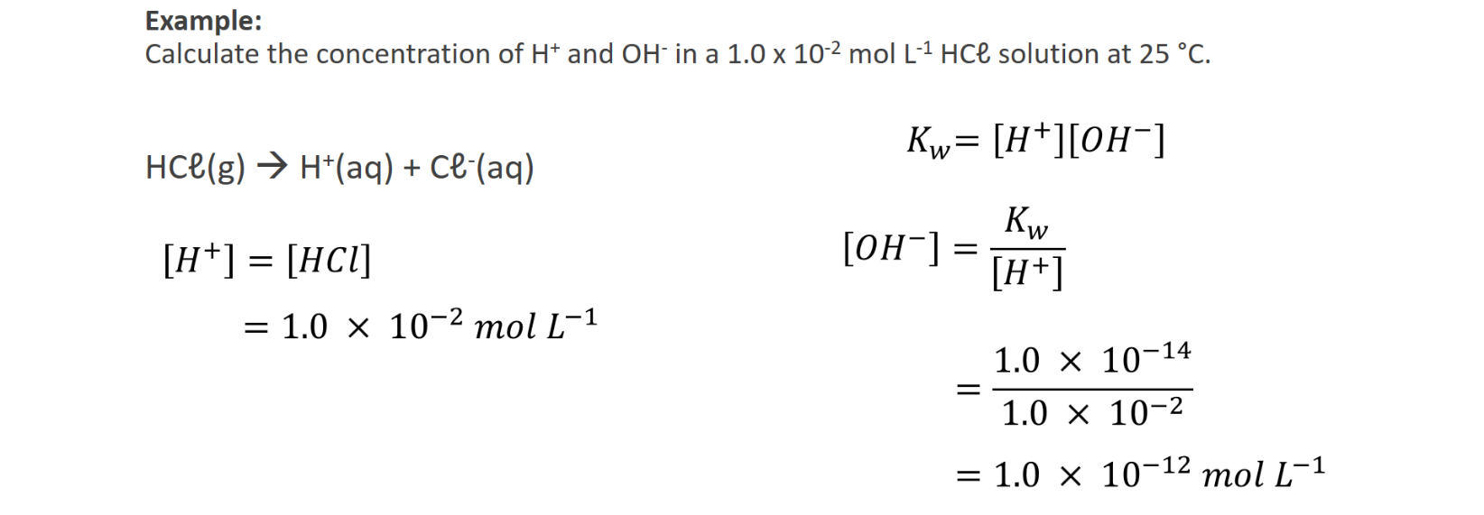



**Questions – Calculating [H+] and [OH-]**

1. The concentation of acid and base in a swimming pool is critical to maintaining an adequate level of chlorine in the water. The concentration of hydrogen ions in the water of an olympic swmming pool was measured to be 1.48 x 10-7 mol L-1. Calculate the concentration of hydroxide ions.

1. Water in the tailings dam of a gold processing plant was found to have a hydroxide ion concentration of 1.58 x 10-4 mol L-1. Calculate [H+].

1. Calculate the hydrogen ion concentration in the following solutions.
2. A standard 1.55 x 10-4 mol L-1 sodium hydroxide solution used for analysing the acid content of wine.

1. A 3.90 x 10-2 mol L-1 barium hydroxide solution used to make soap. **Careful!** **This calculation involves a sneaky trick!**

1. Calculate the hydroxide ion concentration in the following solutions.
2. A standard 0.104 mol L-1 hydrochloric acid used to analyse floor cleaning solutions.

1. A 0.125 mol L-1 sulfuric acid solution used to dissolve samples of of malachite. Assume that the first hydrogen is fully ionised and the second hydrogen is 10.0% ionised.

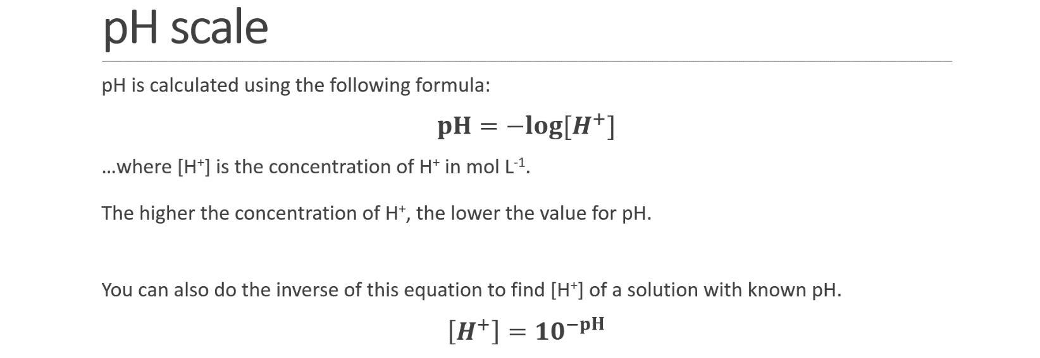

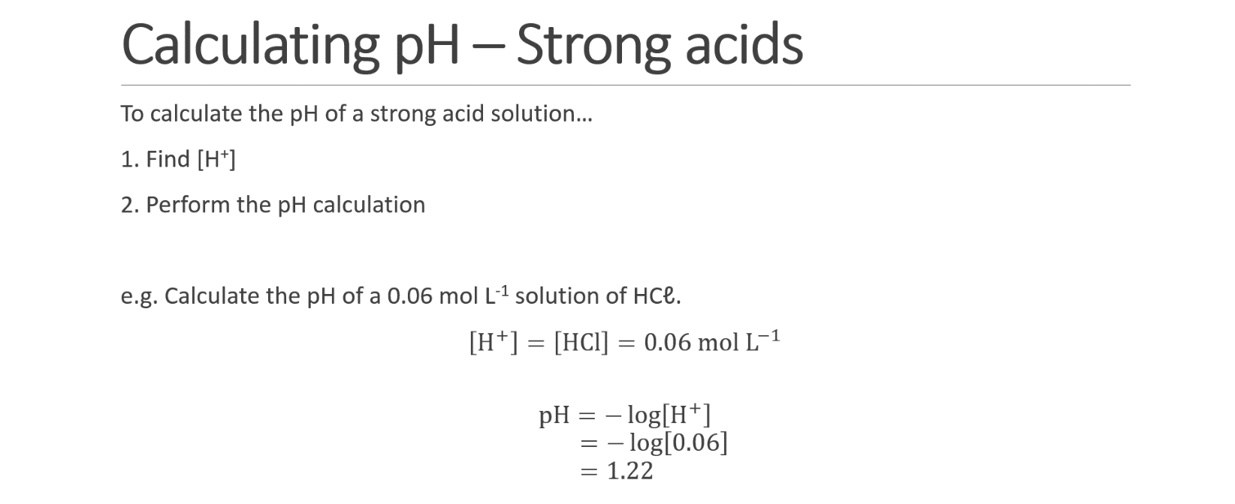

**Q:** Calculate the pH of a 5.0 x 10-3 mol L-1 solution of HNO3

**Q:** 2 litres of hydrogen chloride gas (HCℓ) is collected at S.T.P. and is dissolved in 500 L of water. Calculate the pH of the resulting solution.

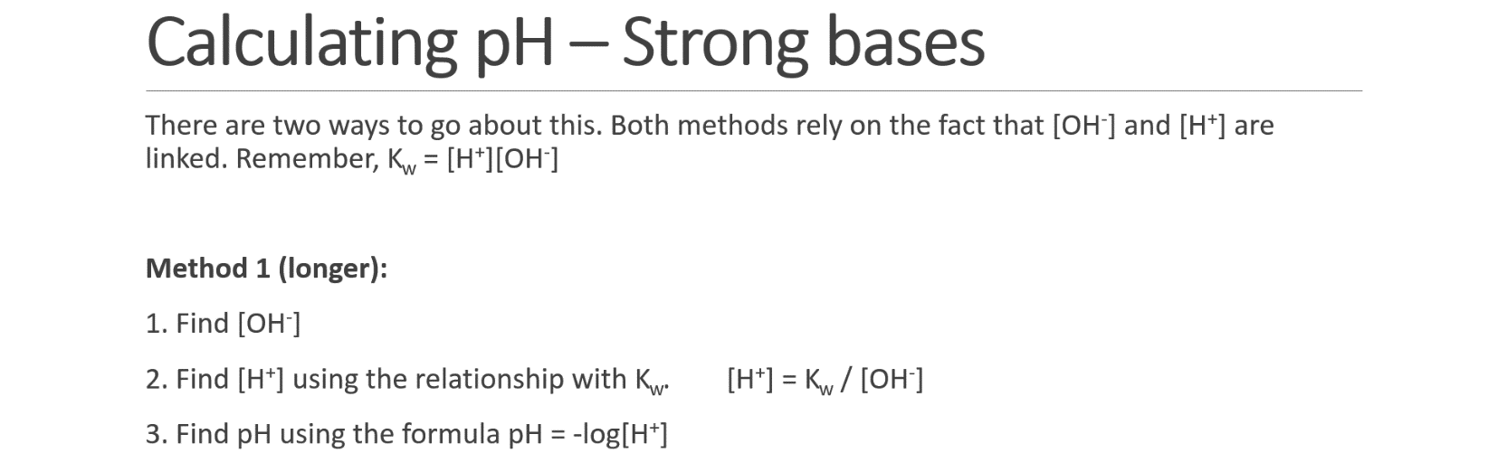

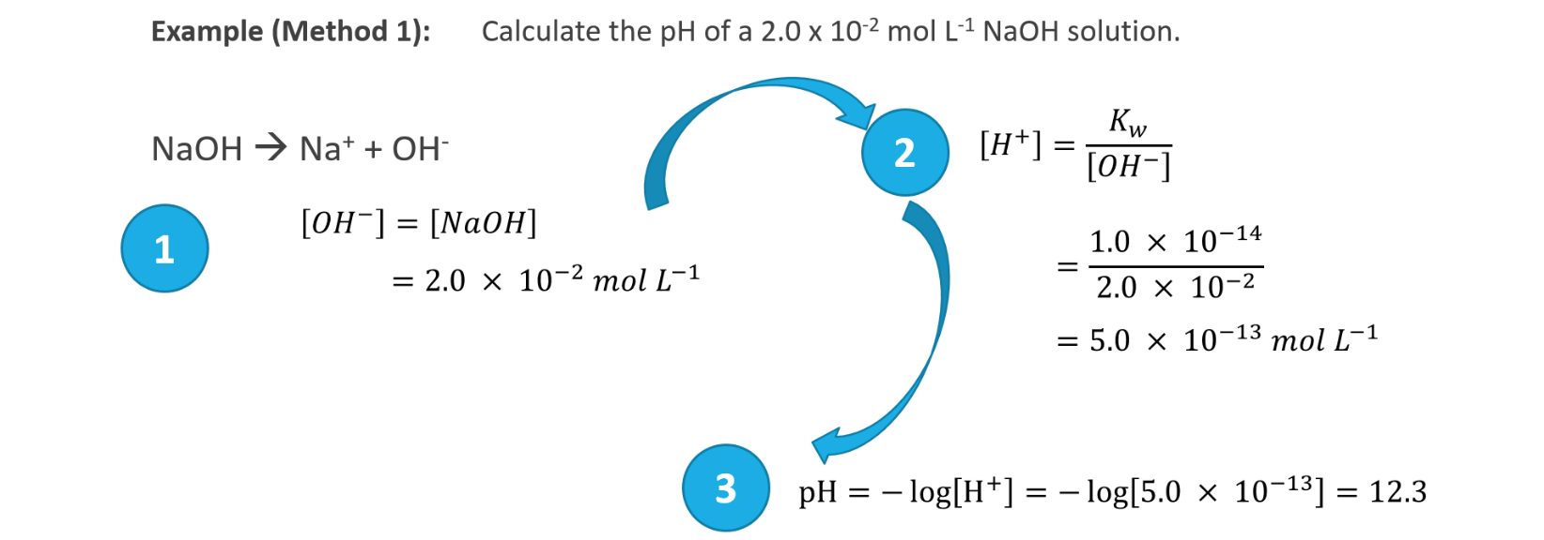

**Q:** Calculate the pH of the following solution using **Method 1** shown above:

1. A 0.0065 mol L-1 solution of KOH

1. A 6.5 x 10-4 mol L-1 solution of Ba(OH)2 **Be careful when calculating [OH-]**

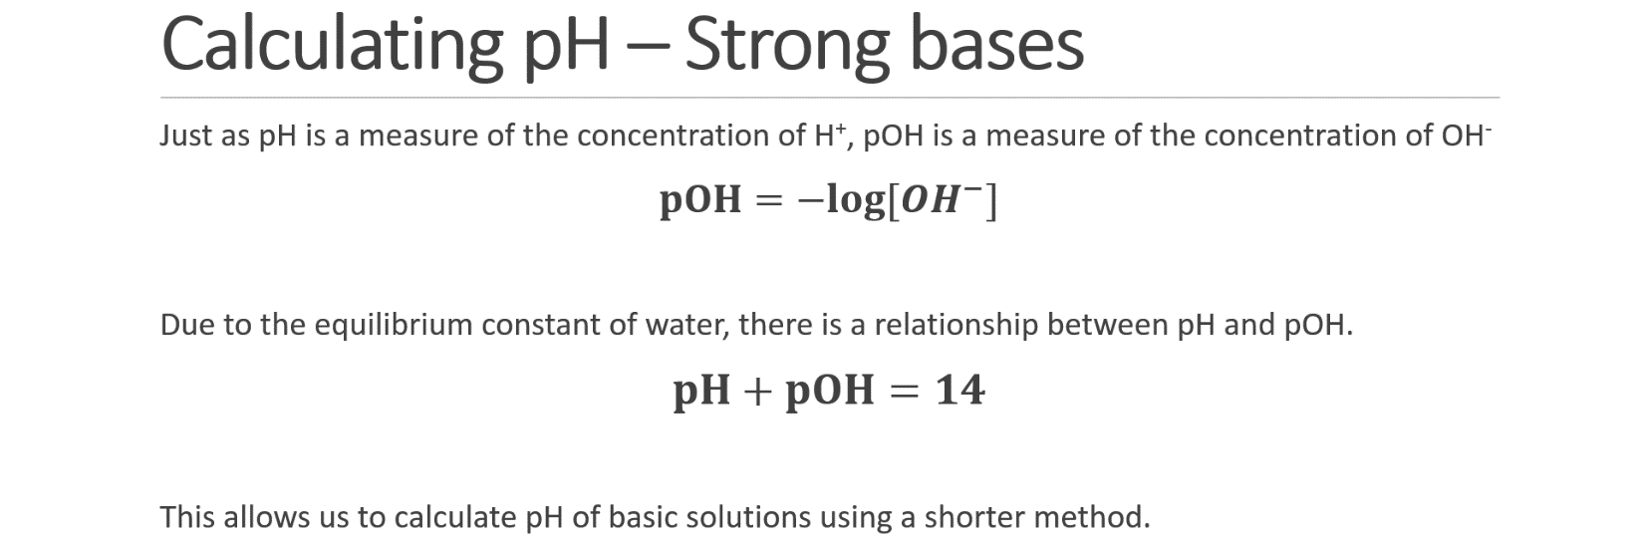

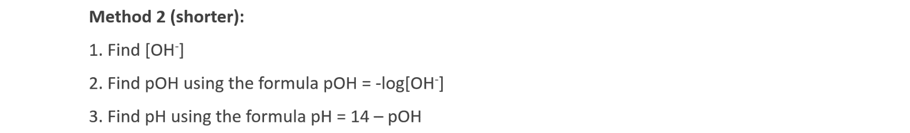

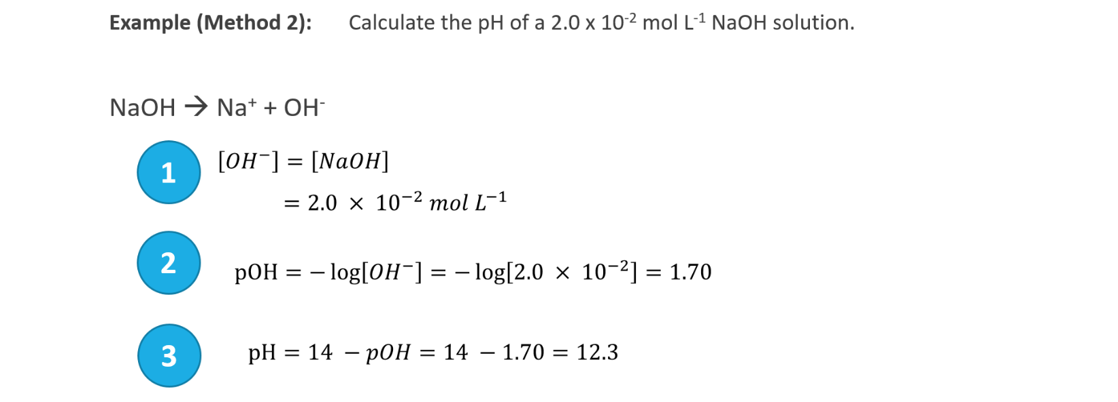

**Q:** Calculate the pH of the following solution using **Method 2** shown above:

1. A 0.000024 mol L-1 solution of KOH

1. A 7.5 x 10-2 mol L-1 solution of Ba(OH)2 **Be careful when calculating [OH-]**

**Questions – pH calculations**

1. Calculate the [H+], [OH-] and pH of the following solutions.
   1. A 0.00500 mol L-1 HNO3 solution used to reduce the pH of nutirent solutions used for hydroponics

* 1. A 0.0100 mol L-1 standard NaOH solution used to analyse vinegar solutions

* 1. A 2.00 mol L-1 HCℓ solution used to dissolve limestone prior to analysis

1. Calculate the [H+] and [OH-] of solutions with the following pH:
   1. Lemon juice of pH 3.00

* 1. Dish washing solution of pH 11.0

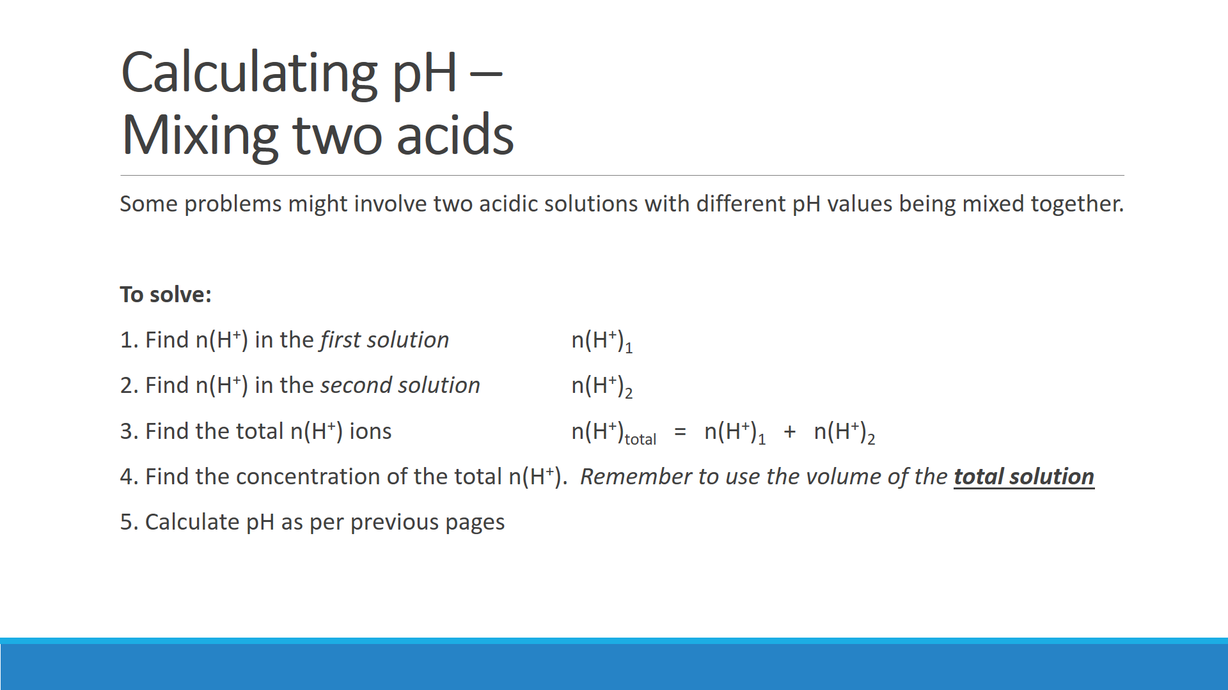

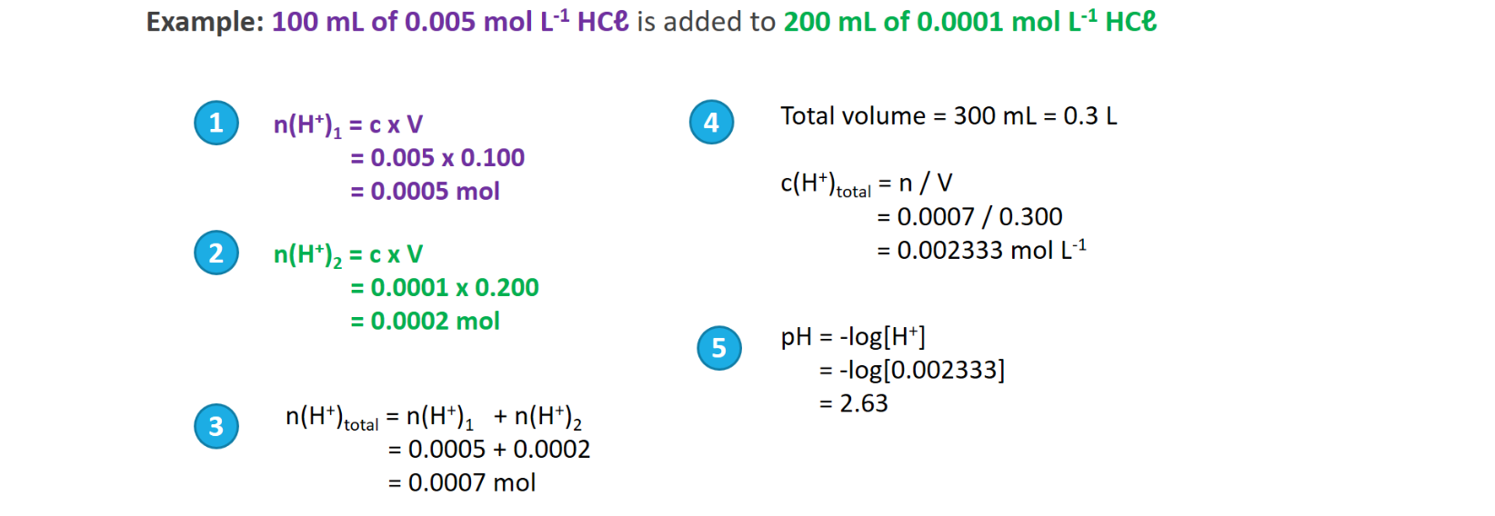

**Question – Mixing acids**

A brick cleaner needs to replenish the hydrochloric acid solution he is using. Using a pH meter he measures the pH of his depleted solution to be 2.00. He decides to add 3.00 L of 3.00 mol L-1 HCℓ solution to 2.00 L of his solution. Calculate the pH of the new solution.

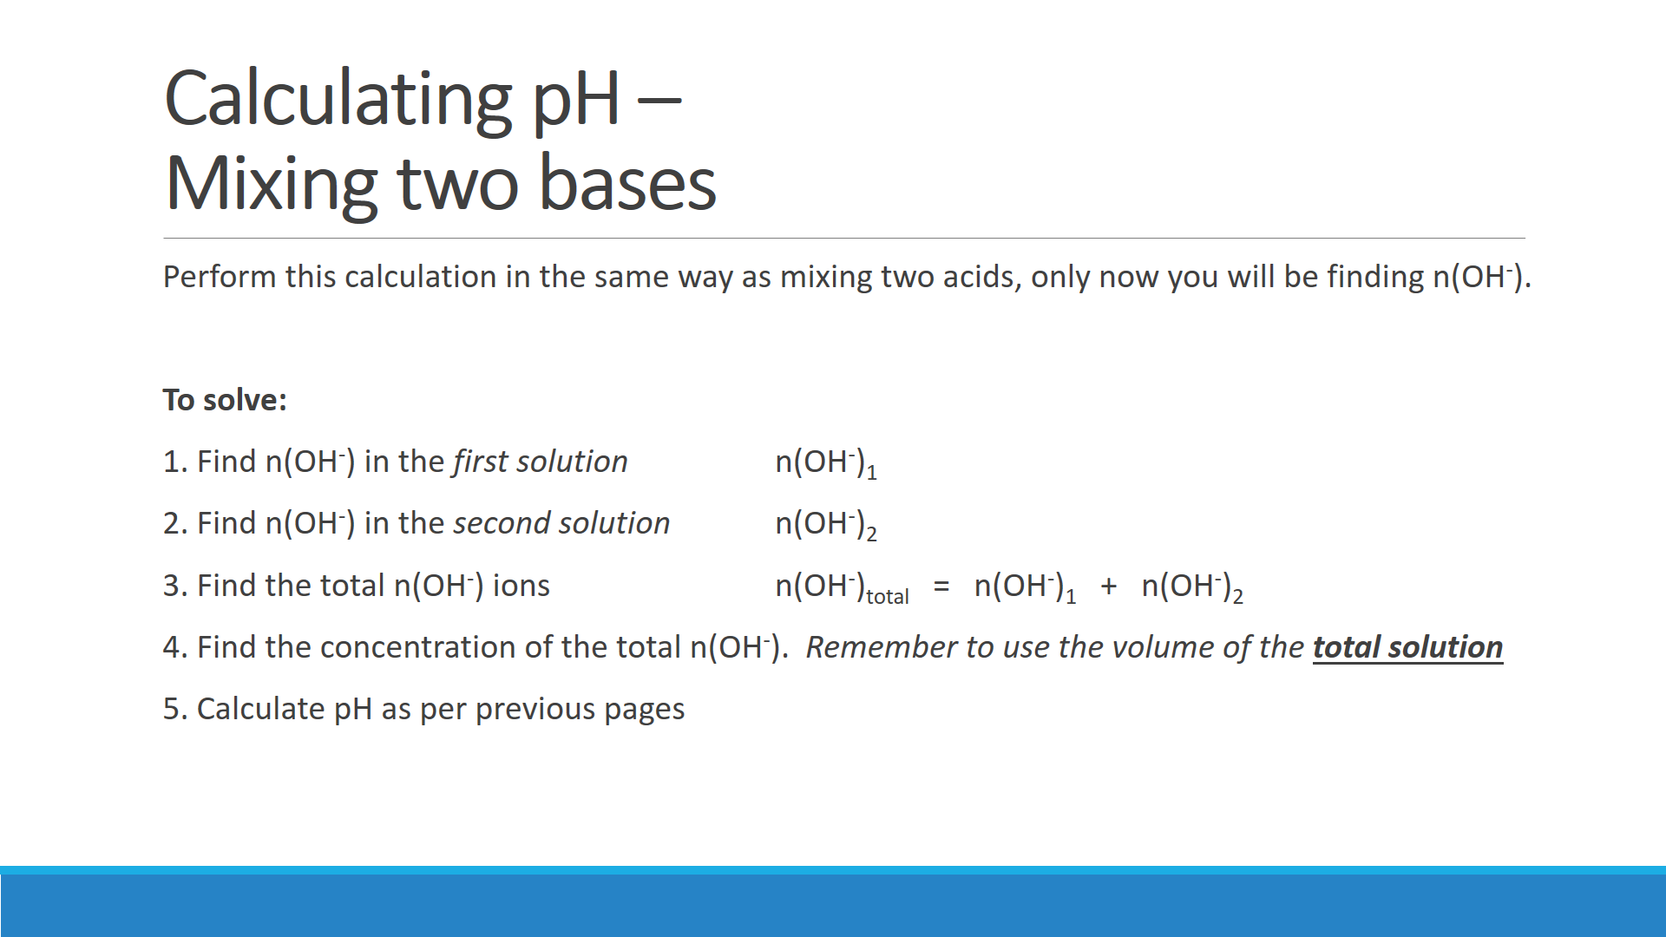

**Question – Mixing bases**

An environmental chemist is conducting research into highly alkaline solutions found in a drain near a concrete batching plant. The concentration of the solution from the drain was found to be 0.236 mol L-1 hydroxide ion and the runoff from the plant was found to have a concentration of hydroxide ion of 0.156 mol L-1. The chemist mixed 200 mL of the solution from the drain with 300 mL of the runoff from the plant.

Calculate the pH of the resulting solution:

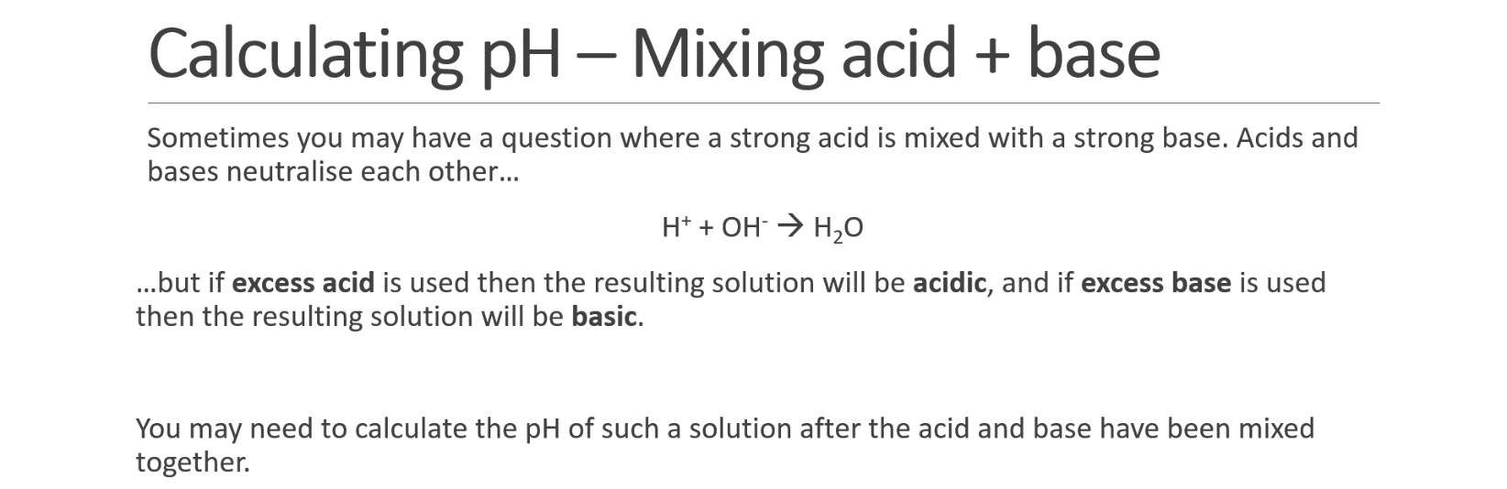

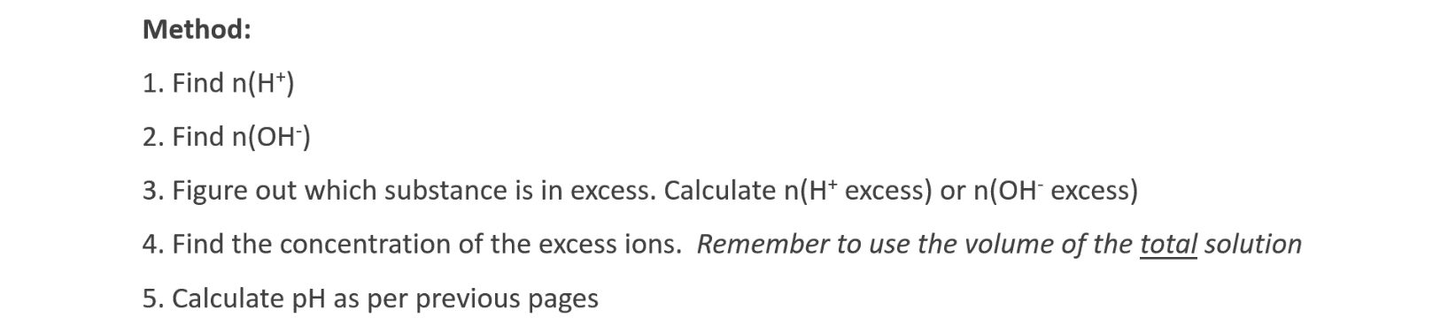



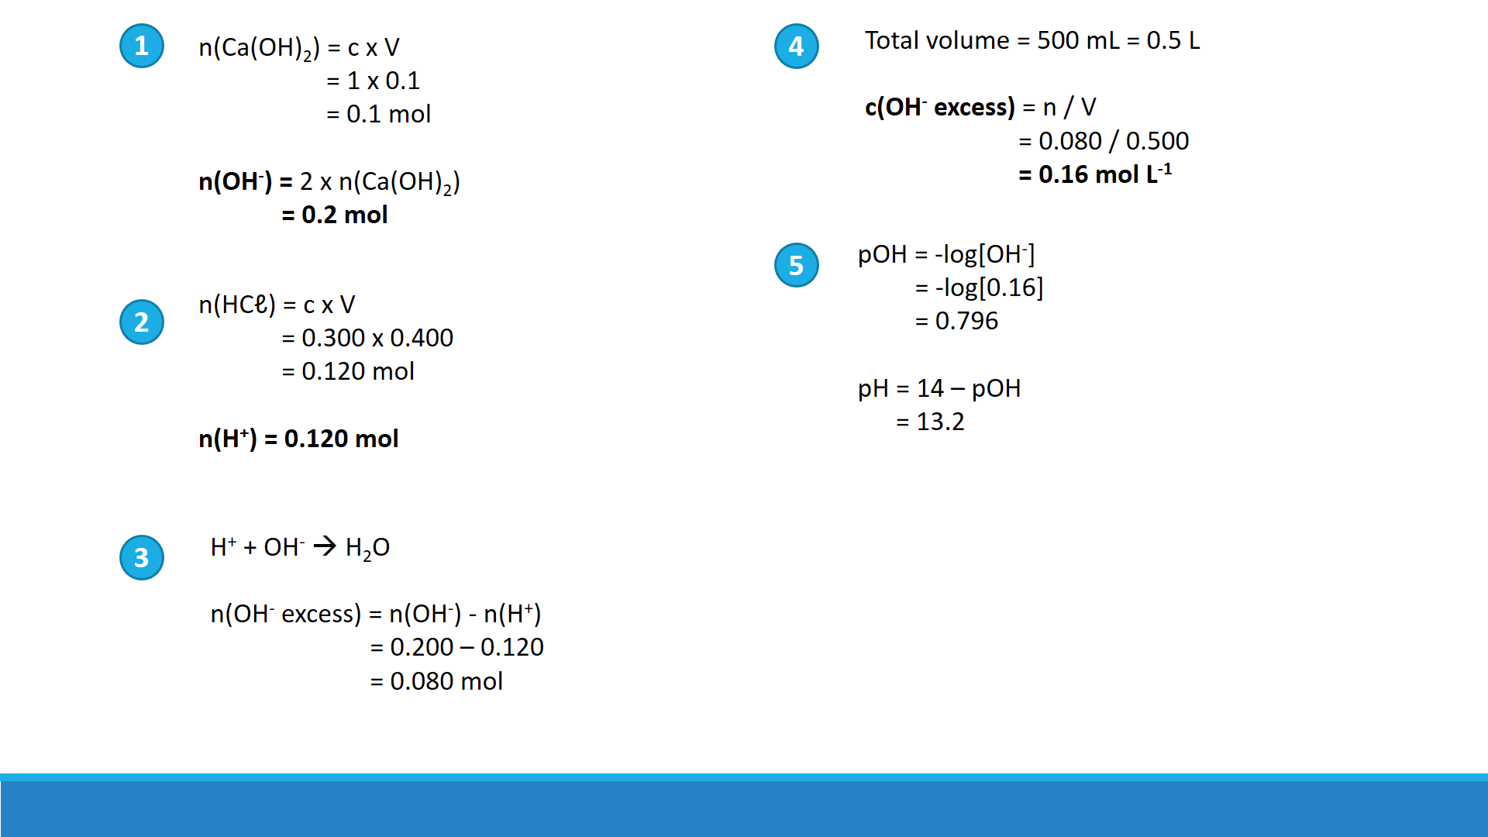

**Questions – Mixed acid-base pH calculations**

Calculate the pH when the following solutions are mixed:

1. 200 mL of 0.1 mol L-1 sodium hydroxide and 300 mL of 0.1 mol L-1 hydrochloric acid

1. 200 mL of 0.1 mol L-1 sodium hydroxide and 300 mL of 0.1 mol L-1 sulfuric acid

1. When you suffer from an acid stomach, the fluid in your stomach can contain hydrochloric acid at a concentration of 2.50 x 10-4 mol L-1. To reduce the amount of acid in your stomach you are advised to take an antacid tablet that contains 5.00 mg of aluminium hydroxide and 5.00 mg of magnesium hydroxide. If at this time you have 1.50 L of fluid in your stomach, calculate the [H+], [OH-] and pH of your stomach after you have taken the tablet. Assume that the presence of the tablet does not change the volume of the solution in your stomach.

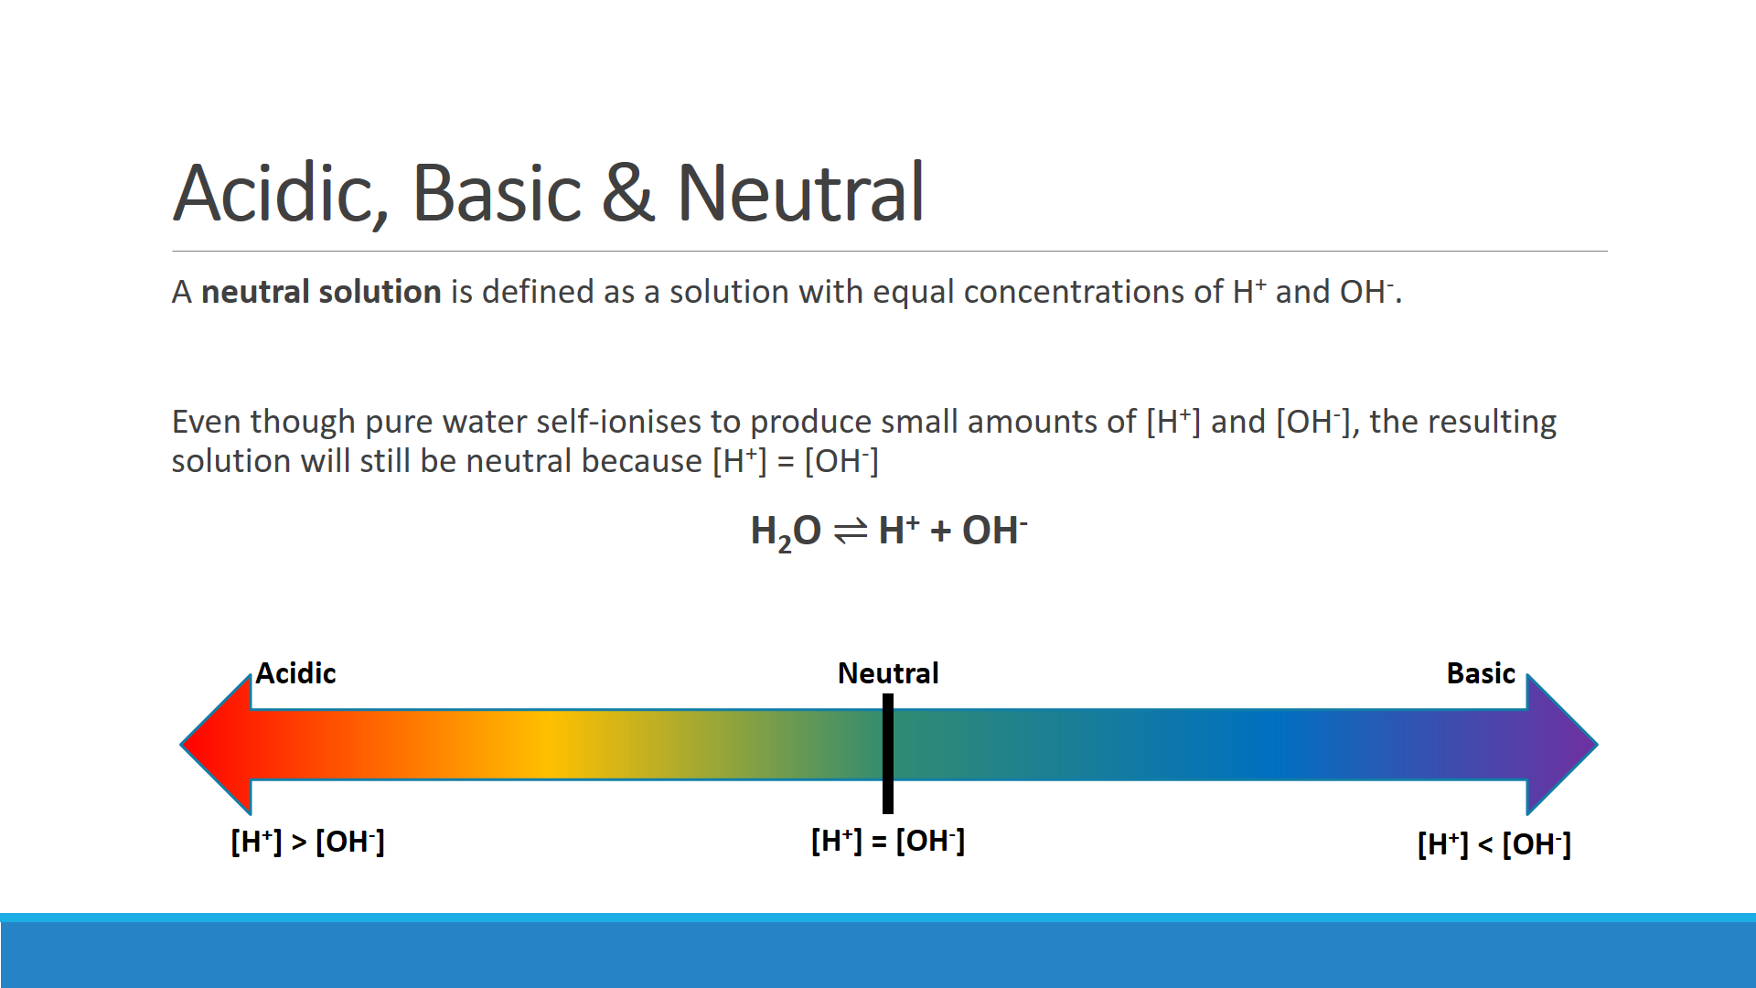

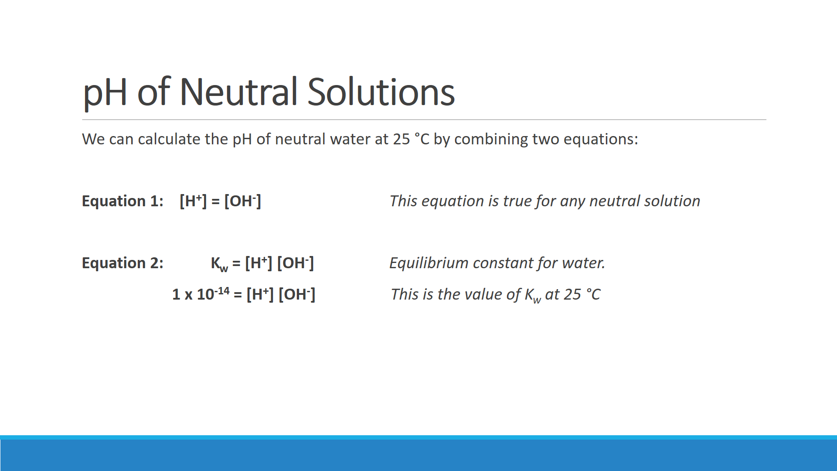



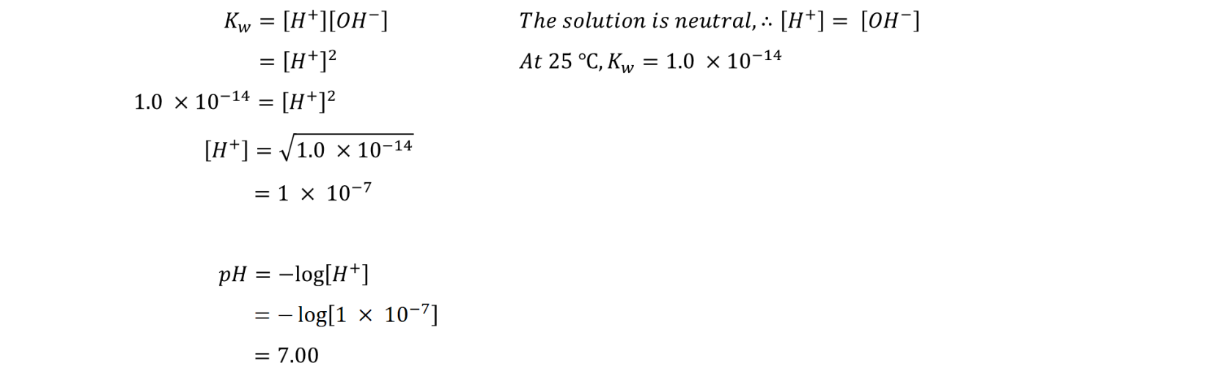

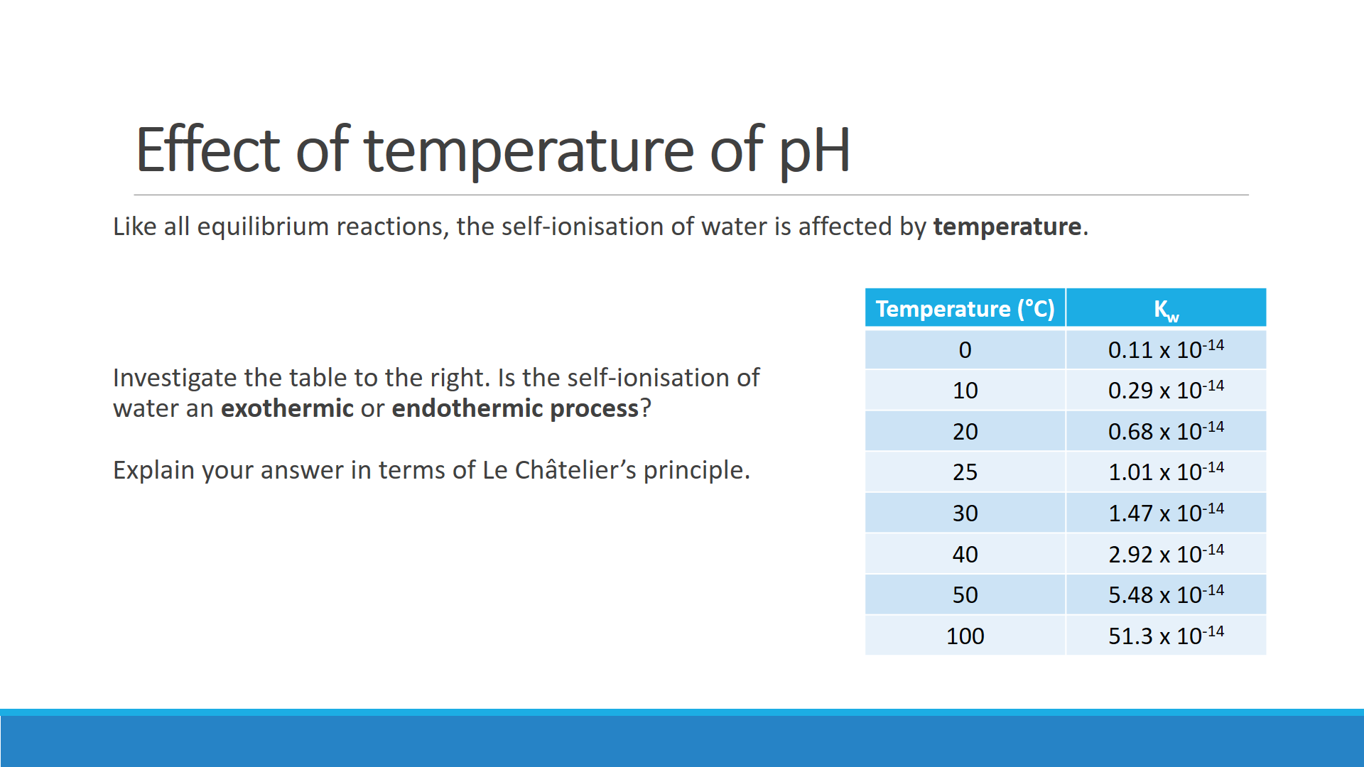



**Q:** Calculate the pH of water at the following temperatures. Use the Kw values from the table above.

1. Neutral water at 10 °C

1. Neutral water at 50 °C

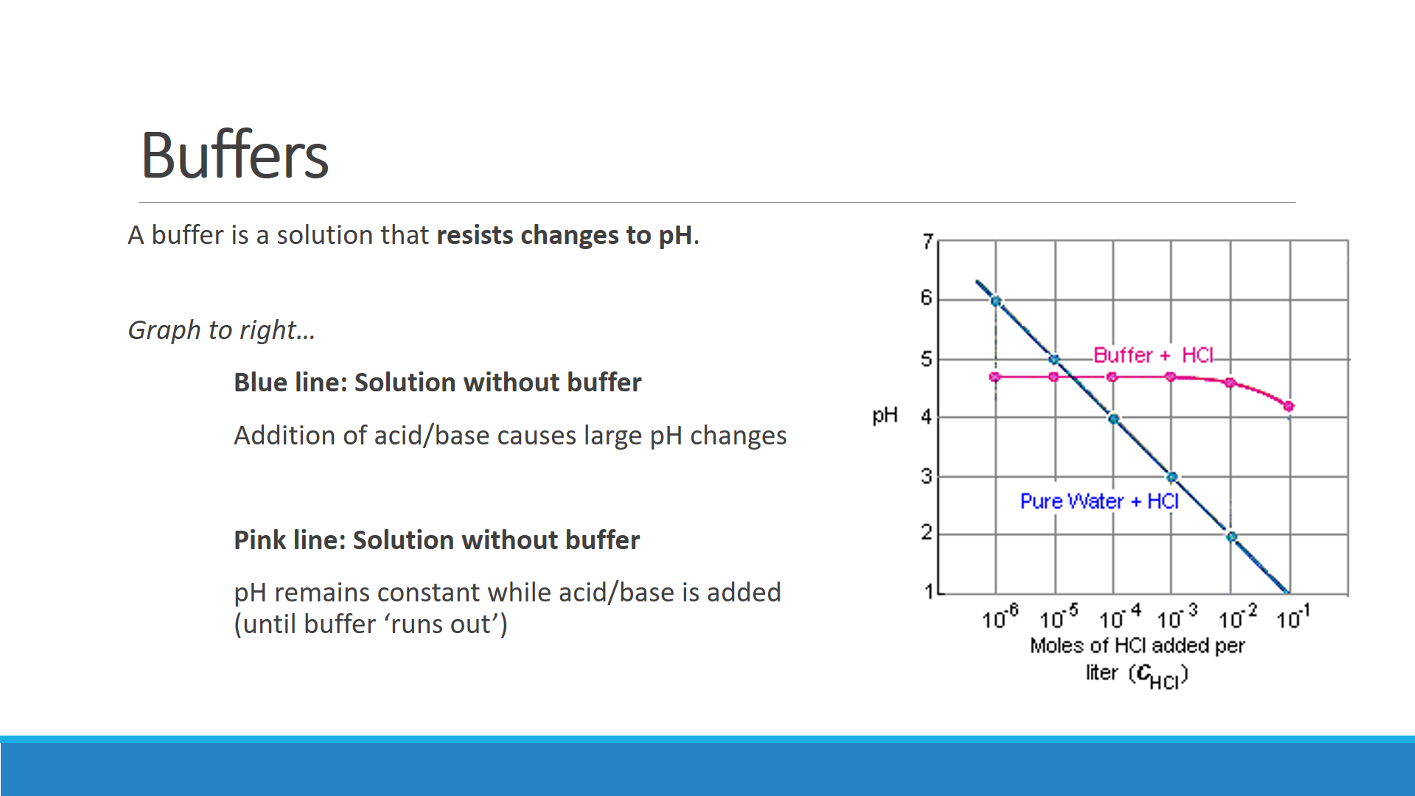

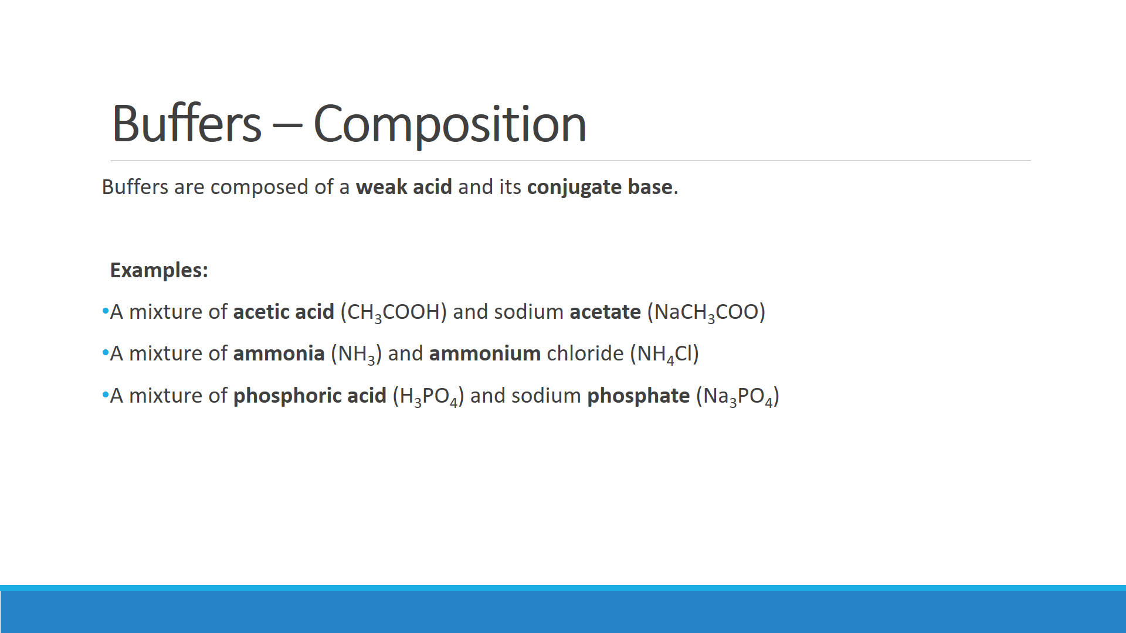

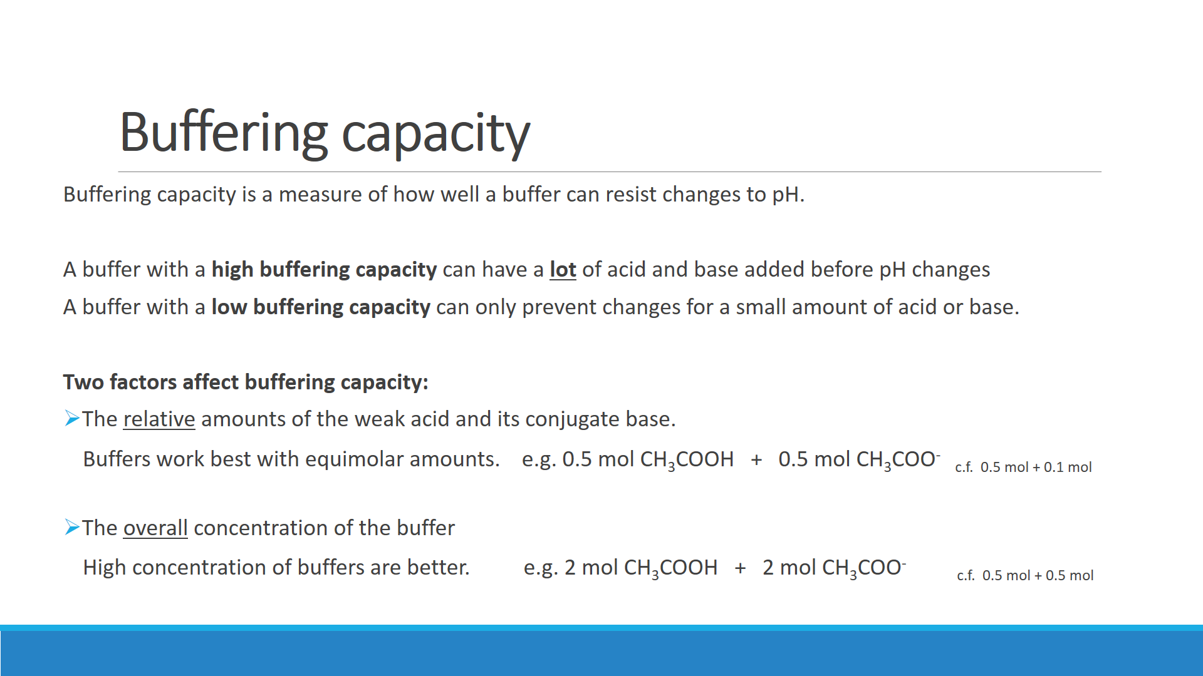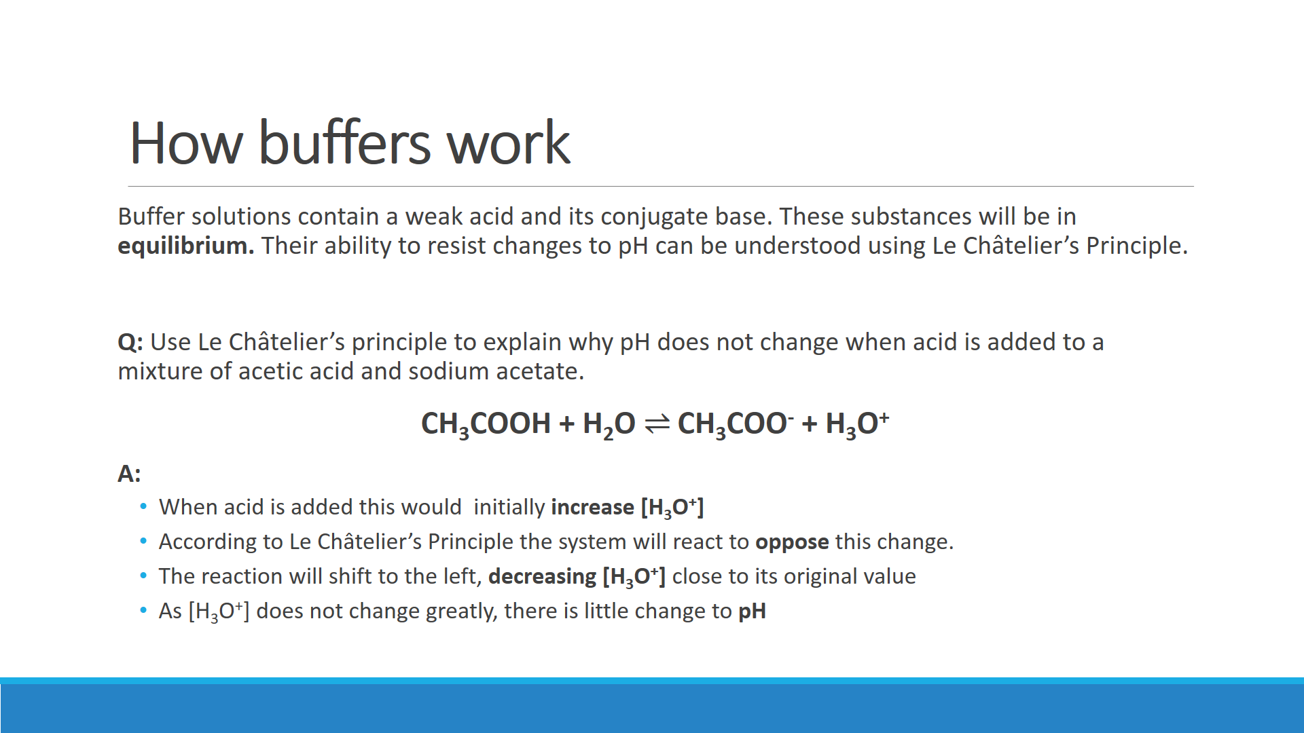

Use Le Châtelier’s principle to explain why pH does not change when sodium hydroxide is added to a mixture of acetic acid and sodium acetate.

Use Le Châtelier’s principle to explain why pH does not change when acid is added to a mixture of sodium hydrogencarbonate and sodium carbonate.

Explain why a mixture of ntiric acid and sodium nitrate would **not** make a good buffer.

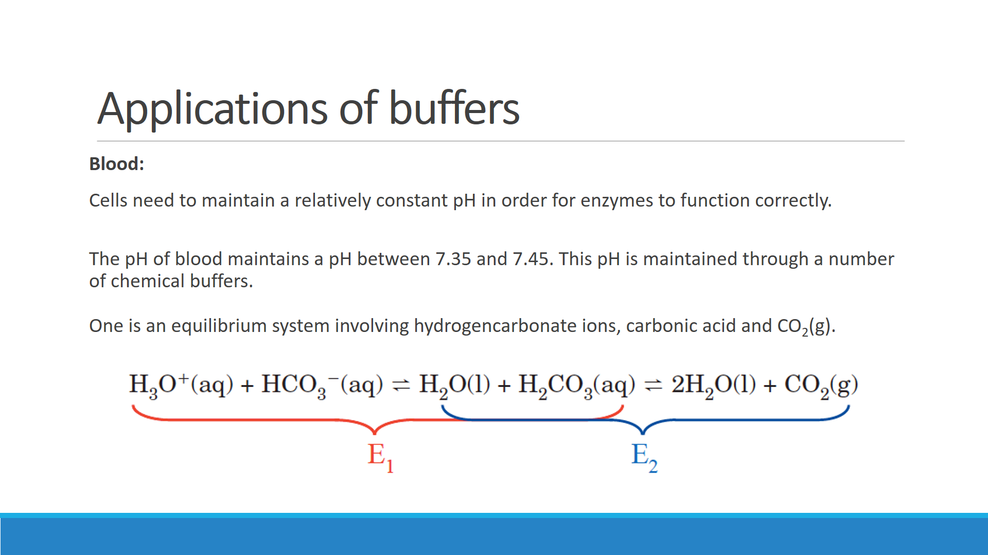

Lactic acid is produced during exercise. The lactic acid enters the bloodstream and could potentially change the pH of blood. Explain, using Le Châtelier’s principle, why the pH of blood stays relatively constant even when the body produces lactic acid.

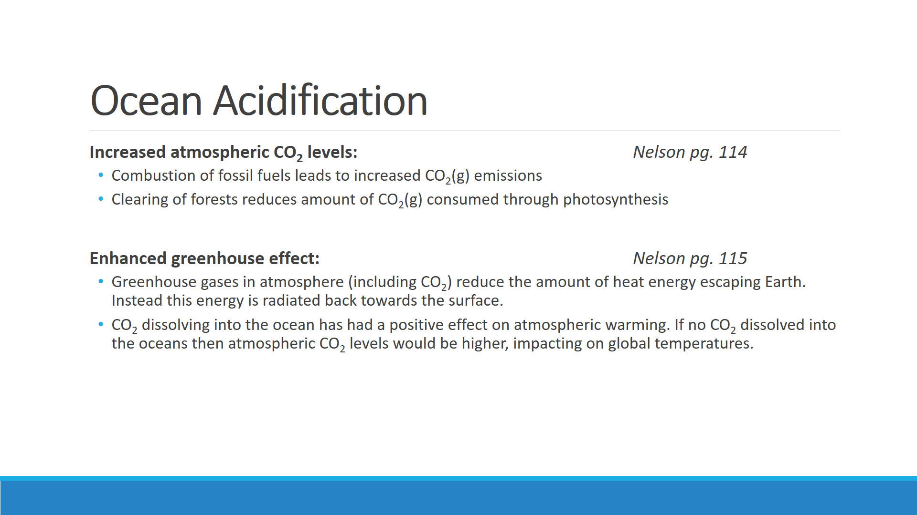

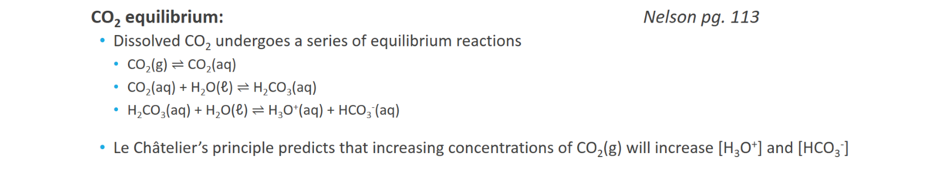

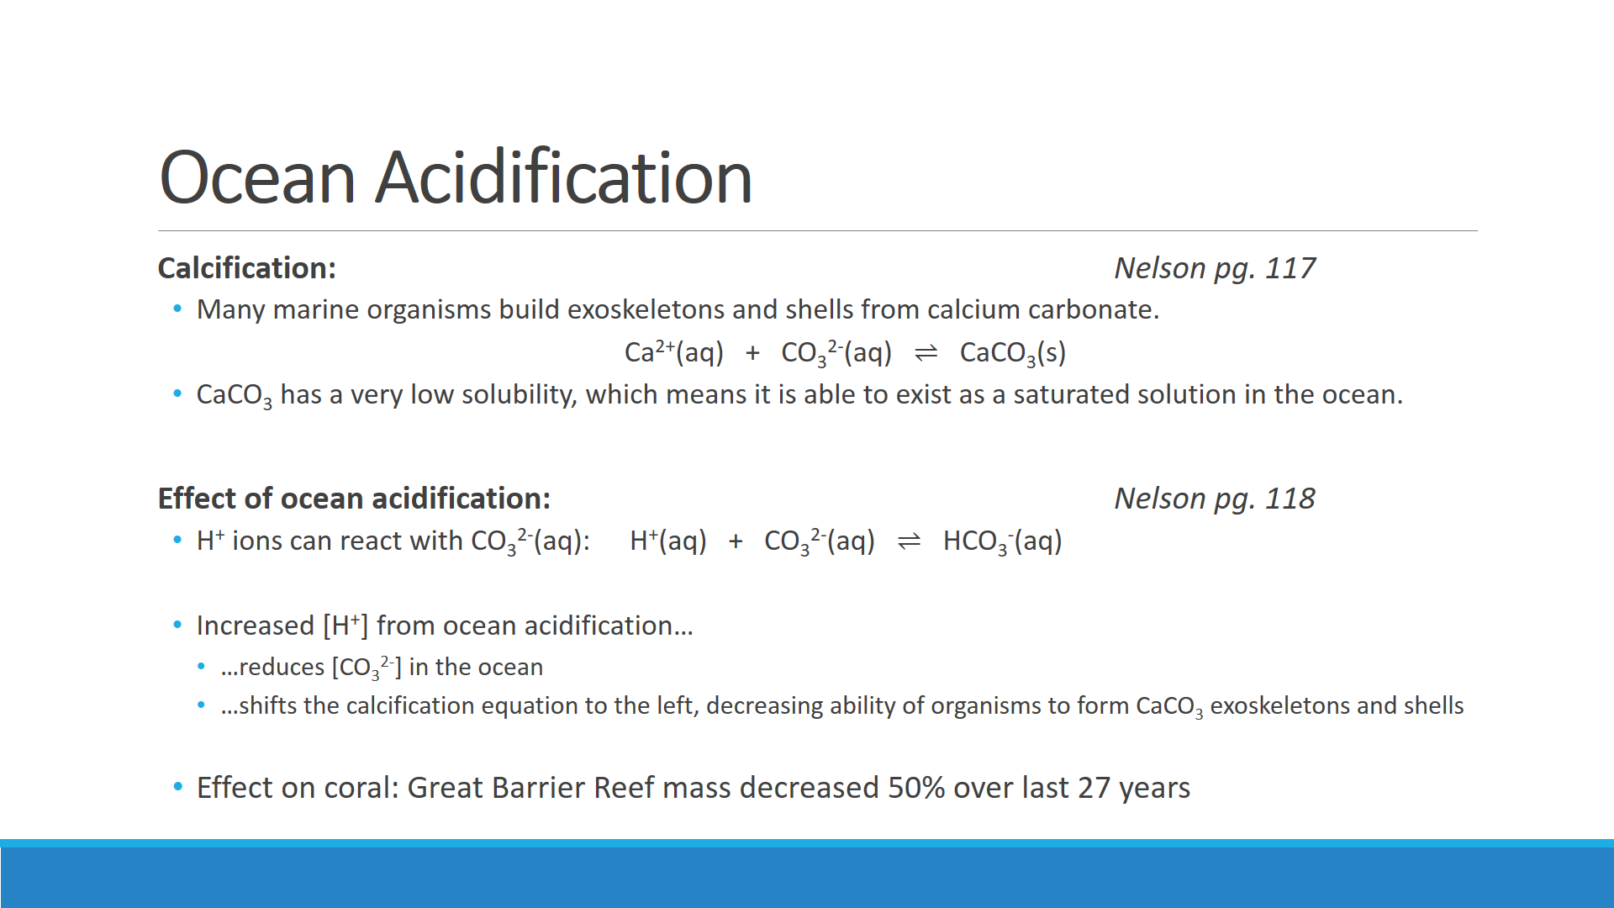

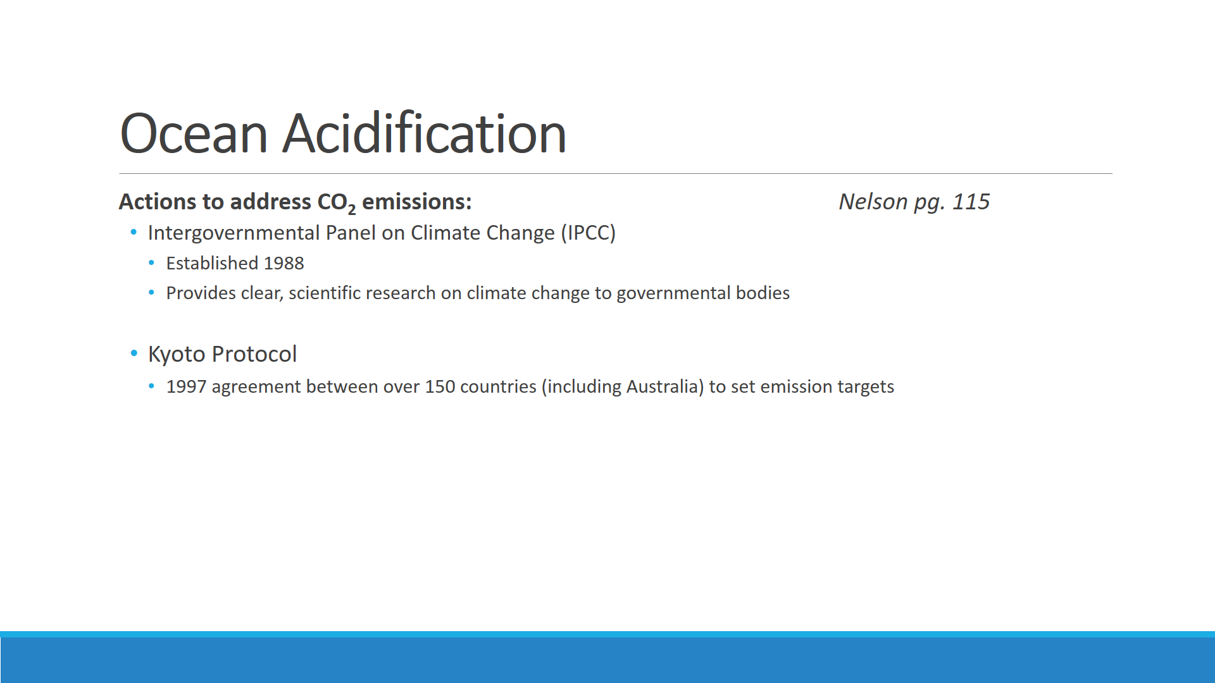

**OCEAN ACIDIFICATION IS A POTENTIAL EXTENDED RESPONSE QUESTION**

**Syllabus:**

Levels of carbon dioxide in the atmosphere are rising and have a significant impact on global systems, including surface temperatures. The increasing level of carbon dioxide in the atmosphere causes more carbon dioxide to dissolve in the ocean producing carbonic acid and leading to increased ocean acidity. This is predicted to have a range of negative consequences for marine ecosystems such as coral reefs. Calcification is the process which results in the formation of calcium carbonate structures in marine organisms. Acidification shifts the equilibrium of carbonate chemistry in seawater, decreasing the rate and amount of calcification among a wide range of marine organisms. The United Nations Kyoto Protocol and the Intergovernmental Panel on Climate Change aim to secure a global commitment to reducing greenhouse gas emissions over the next few decades.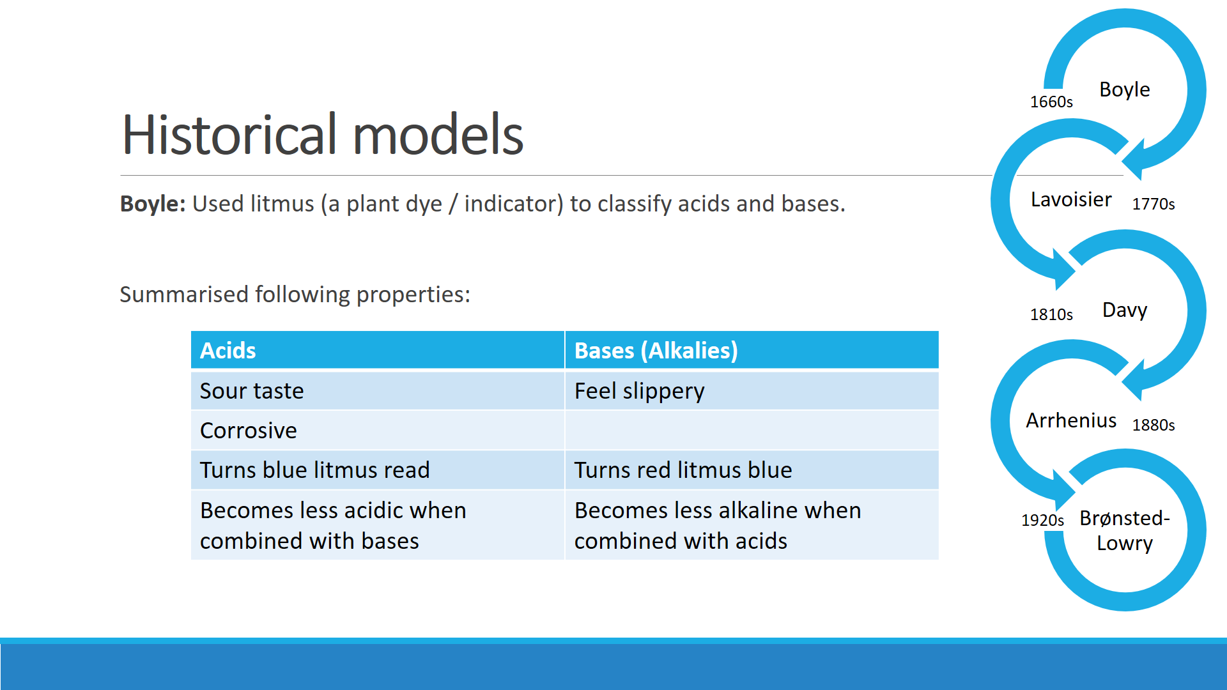

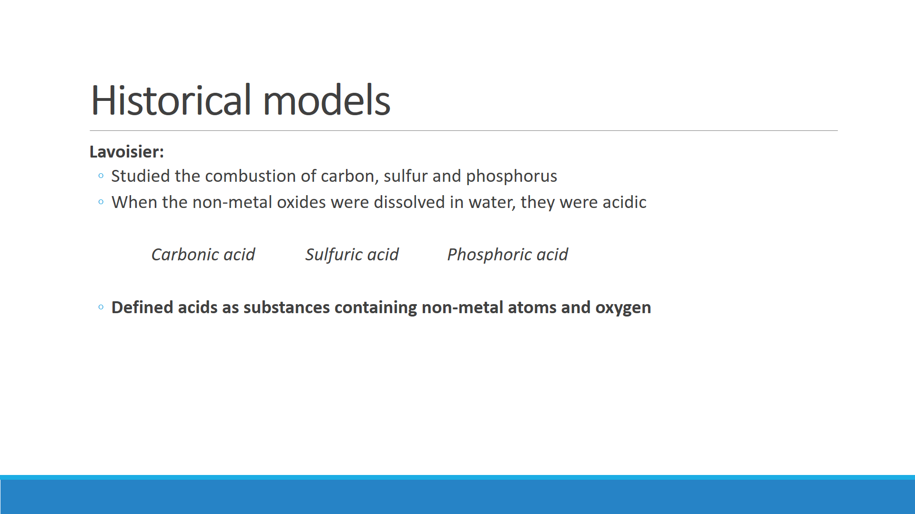

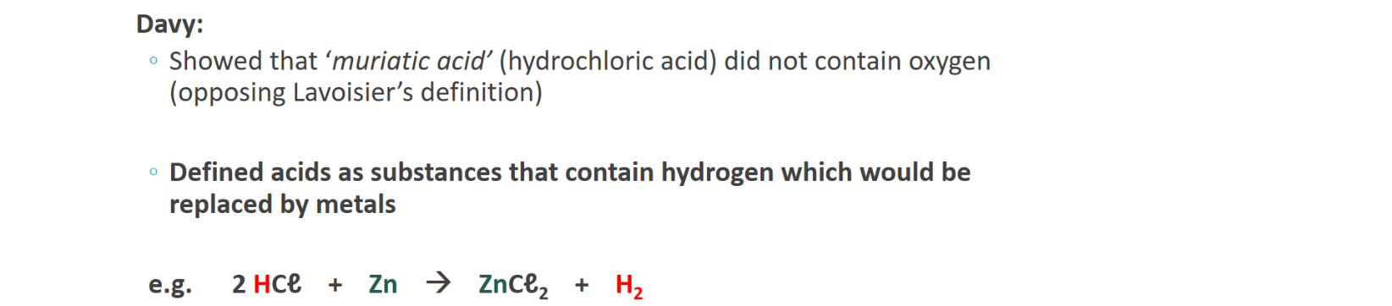

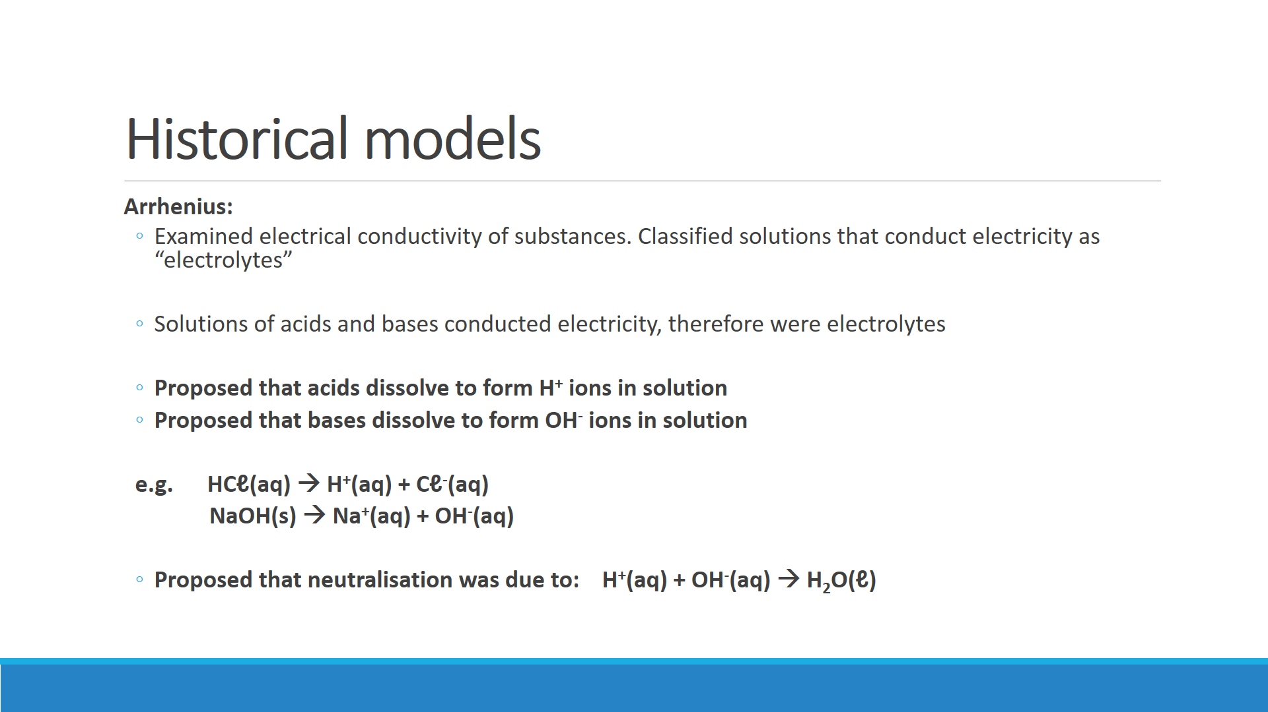

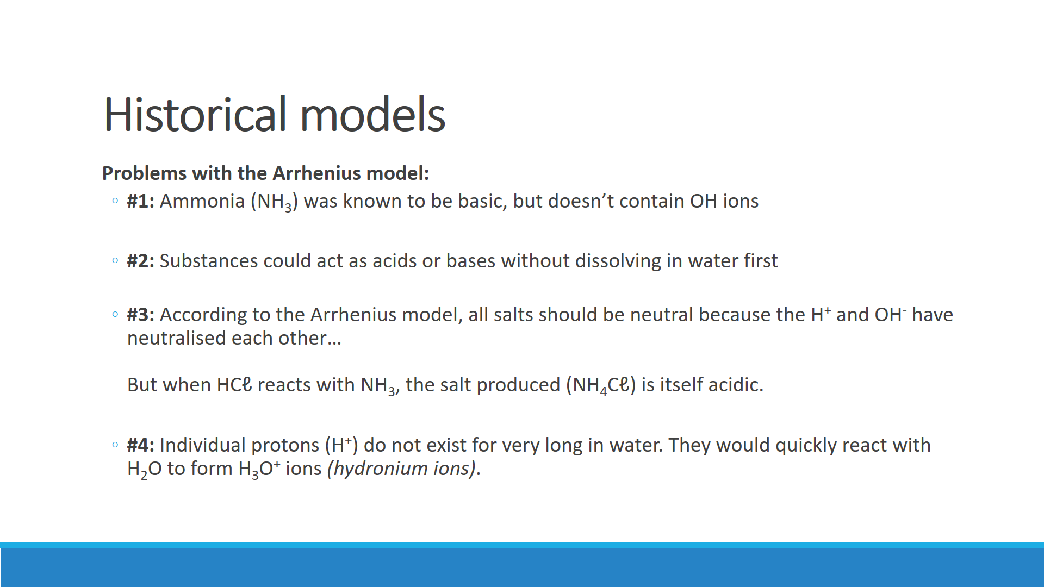

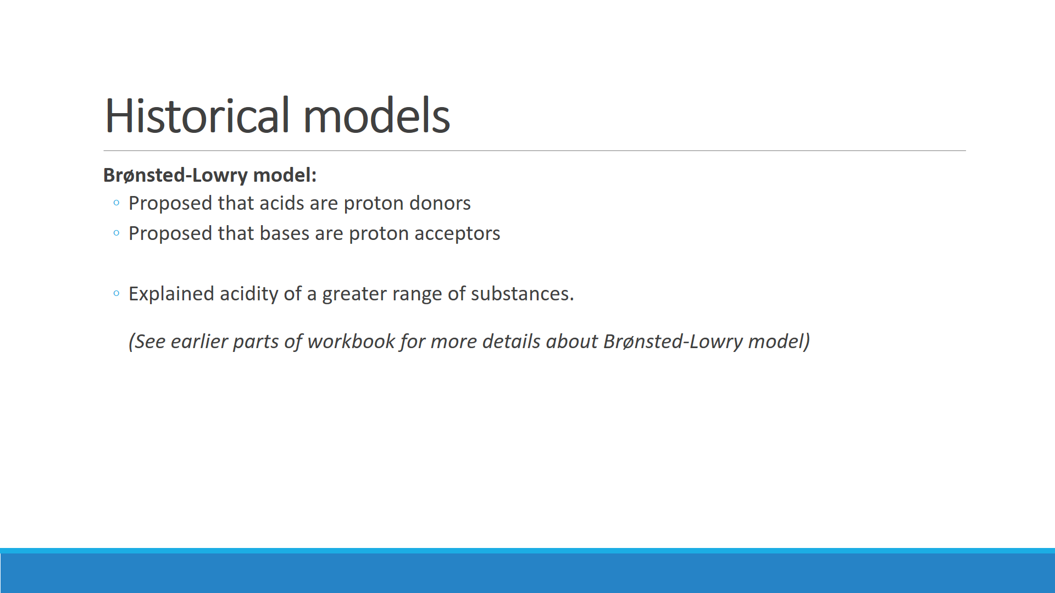

**MODELS OF ACIDS & BASES IS A POTENTIAL EXTENDED RESPONSE QUESTION**

|  |  |
| --- | --- |
| **What the syllabus says** | **Key ideas** |
| Models and theories are contested and refined or replaced when new evidence challenges them, or when a new model or theory has greater explanatory scope. | * **“Models and theories”**   Be able to explain what models and theories refer to, and be able to correctly use t   * **“contested and refined […] new evidence”** Explain how new evidence contradicted previous models, and how this lead to the development of newer models |
| **Davy** initially proposed that acids were substances that contained replaceable hydrogen (hydrogen that could be partly or totally replaced by metals) and bases were substances that reacted with acids to form salts and water. | * Clearly outline Davy’s model * Give supporting evidence that Davy used to justify model * Be able to write equations to illustrate |
| The **Arrhenius model**, which includes only soluble acids and bases, identified acids as substances which produce hydrogen ions in solution and bases as substances which produce hydroxide ions in solution. | * Clearly outline the Arrhenius model * Give supporting evidence that Arrhenius used to justify model * Be able to write equations to illustrate * Note the importance of “**only includes soluble acids and bases”** with regards to limitations |
| Subsequently, the **Brønsted-Lowry model** describes acid-base behaviour in terms of proton donors and proton acceptors. | * Clearly outline the Brønsted-Lowry model * Give supporting evidence that Brønsted-Lowry used to justify model * Be able to write equations to illustrate |
| [The Brønsted-Lowry] approach includes a wider range of substances and can be more broadly applied. | * Compare the models of Davy, Arrhenius and Brønsted-Lowry in regards to what substances they can be applied to |

**HOMEWORK:**

|  |  |  |  |
| --- | --- | --- | --- |
| **Topic** | **Source** | **Set/Chapter** | **Questions to complete** |
| Reactions of acids and bases | CWA1 | 13.6 | 1 |
| Acid-Base theory   * Brønsted-Lowry * Polyprotic acids * Conductivity * Strong & weak acids | Nelson | 2.1 | 2 3 4 5 6 7 8 9 |
| Nelson | 2.2 | 1 2 5 |
| AA | 2.3 | 2.6 2.7 2.8 |
| CWA1 | 13.4 | 1 2 |
| CWA1 | 13.5 | 1 2b |
| CWA2 | 7.1 | 1 2 4 5 6 7 8 |
| Acid-base equilibrium, Ka | Nelson | 2.3 | 1 2 |
| CWA2 | 7.1 | 9 |
| Hydrolysis of salts | AA | 2.4 | 2.9 2.10 |
| CWA2 | 7.2 | 3a 3b 4a 4b 4c |
| Kw and pH | Nelson | 2.2 | 4 6 7 8 |
| AA | 2.2 | 2.1 2.2 2.3 2.4 2.5 |
| AA | 2.5 | 2.13a |
| CWA1 | 13.7 | 1 2 3 4 |
| CWA2 | 7.3 | 1 2 3 4 5 |
| Buffers | Nelson | 2.4 | 1 3 7 |
| AA | 2.5 | 2.11 2.12 |
| CWA2 | 7.4 | 1 2 3 |
| Ocean acidification | Nelson | 2.4 | 5 |
| Chapter review | Nelson | Chapter 2 Review | 1 2 3 4 5 6 9 11 12 16a 17a 17b |
| AA | Chapter 2 Review | 1 2 3 4 5 6 7 8 9 10 11 12 13 14 15 16 |

Nelson = Nelson Chemistry Units 3 & 4 CWA1 = Chemistry for WA 1

AA = Academic Associates WACE Study Guide CWA2 = Chemistry for WA 2